DEFGEN021 Take photographs suitable for publication within Defence
Release: 1

DEFGEN021 Take photographs suitable for publication within Defence

Modification History
Release | Comments
1 | This unit was released in DEF Defence Training Package release 1.0 and meets the Standards for Training Packages.  This unit supersedes and is equivalent to DEFPR305B Take photographs suitable for publication within Defence.  - Unit code updated  - Content and formatting updated to comply with the new standards  - All PC transitioned from passive to active voice  - PC 3.1 reworded  - PC 4.2 revised

Application
This unit describes the skills required to take suitable photographs for incorporation within a Defence publication. This includes basic photographic techniques such as composition, lighting and layout. All Defence reporters are required to take photographs in a variety of formats suitable for publication in a range of publications. Generally the reporter determines the need, type and context of the photographs, but in some cases this will be under direction from senior reporters or the editor.
Reporters either work in a controlled environment where they can manage photographic activity or in an uncontrolled environment where they anticipate a photographic opportunity but cannot identify its exact timing or nature.
This unit was developed for Defence reporters, but is applicable to anyone working in this field.
The skills and knowledge described in this unit must be applied within the legislative, regulatory and policy environment in which they are carried out. Organisational policies and procedures must be consulted and adhered to.
Those undertaking this unit would mainly work independently seeking assistance from superiors when needed. They would perform specific tasks in known contexts.
No licensing, legislative or certification requirements apply to unit at the time of publication.

Competency Field
General

Elements and Performance Criteria
ELEMENTS | PERFORMANCE CRITERIA
Elements describe the essential outcomes | Performance criteria describe the performance needed to demonstrate achievement of the element. Where bold italicised text is used, further information is detailed in the range of conditions section.
1. Prepare to take a photograph | 1.1 Identify potential need, type and context of photographs to accompany a story.  1.2 Check photographic equipment for serviceability.  1.3 Rectify and report any equipment faults to appropriate personnel, or obtain replacement equipment, or take an alternative approach.  1.4 Assess and determine most appropriate way to get the photograph.  1.5 Seek permission to take the photograph from relevant Defence personnel.  1.6 Explain context of the proposed photograph to the subject to gain willing cooperation and permission.  1.7 Identify and factor operational, security, safety and other considerations affecting taking photographs into planning.  1.8 Detail and record captions.
2. Take a photograph | 2.1 Prepare photographic equipment and select correct technical settings.  2.2 Brief subjects on proceedings.  2.3 Set up photographic sequence, compose and take the photograph.  2.4 Produce photographs of a high quality illustrating stories and suitable for commercial reproduction.
3. Arrange for processing of photographs | 3.1 Retrieve images.  3.2 Make arrangements for photographs to be developed, scanned or otherwise made ready for publication.
4. Transmit photographs | 4.1 Select most suitable means for transmitting photographs.  4.2 Forward photographs for publication.  4.3 Maintain record of transmission.

Foundation Skills
The foundation skills demands of this unit have been mapped for alignment with the Australian Core Skills Framework (ACSF). The following tables outline the performance levels indicated for successful attainment of the unit.

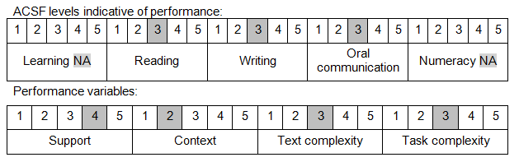

Further information on ACSF and the foundation skills underpinning this unit can be found in the Foundation Skills Guide on the GSA website.

Unit Mapping Information
This unit supersedes and is equivalent to DEFPR305B Take photographs suitable for publication within Defence.

Links
Companion Volume implementation guides are found in VETNet - https://vetnet.gov.au/Pages/TrainingDocs.aspx?q=6bdbab1e-11ed-4bc9-9cba-9e1a55d4e4a9
Companion Volume implementation guides are found in VETNet - https://vetnet.gov.au/Pages/TrainingDocs.aspx?q=6bdbab1e-11ed-4bc9-9cba-9e1a55d4e4a9
Companion Volume implementation guides are found in VETNet - https://vetnet.gov.au/Pages/TrainingDocs.aspx?q=6bdbab1e-11ed-4bc9-9cba-9e1a55d4e4a9

