DEFGEN019 Write material suitable for publication within Defence
Release: 1

DEFGEN019 Write material suitable for publication within Defence

Modification History
Release | Comments
1 | This unit was released in DEF Defence Training Package release 1.0 and meets the Standards for Training Packages.  This unit supersedes and is equivalent to DEFPR303B Write material suitable for publication within Defence.  - Unit code updated  - Content and formatting updated to comply with the new standards  - All PC transitioned from passive to active voice  - PC 2.1 and 2.2, and 3.2 and 3.3 merged  - Elements 2 and 3 merged

Application
This unit describes the skills required to write news features or other journalistic material for Defence publications. In the most part, information for a Defence publication will come from within the organisation. In some cases however, material will be provided from external sources. News features and other material will generally be published in services newspapers, magazines and on internet sites.
This unit was developed for Defence reporters, but is applicable to anyone working in this field.
The skills and knowledge described in this unit must be applied within the legislative, regulatory and policy environment in which they are carried out. Organisational policies and procedures must be consulted and adhered to.
Those undertaking this unit would mainly work independently, seeking assistance from superiors when needed. They would perform complex tasks in known contexts.
No licensing, legislative or certification requirements apply to unit at the time of publication.

Competency Field
General

Elements and Performance Criteria
ELEMENTS | PERFORMANCE CRITERIA
Elements describe the essential outcomes | Performance criteria describe the performance needed to demonstrate achievement of the element. Where bold italicised text is used, further information is detailed in the range of conditions section.
1. Draft the story | 1.1 Identify key story points and reader specific angles.  1.2 Determine appropriate style and maintain throughout the copy.  1.3 Structure draft story and attribute quotes.  1.4 Comply with organisation’s style manual and meet the needs of target audiences when drafting the story.
2. File the story for publication | 2.1 Identify, and factor into planning, public affairs objectives/constraints and client needs.  2.2 Clear the story with the subject as appropriate.  2.3 Submit story for proofreading and clearance by the senior reporter and amend accordingly.  2.4 File story after being assessed as publication quality.  2.5 Recognise and meet deadlines.

Foundation Skills
The foundation skills demands of this unit have been mapped for alignment with the Australian Core Skills Framework (ACSF). The following tables outline the performance levels indicated for successful attainment of the unit.

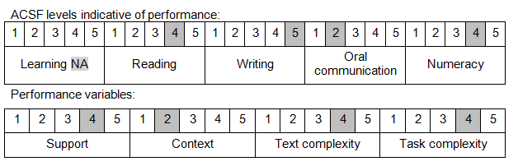

Further information on ACSF and the foundation skills underpinning this unit can be found in the Foundation Skills Guide on the GSA website.

Unit Mapping Information
This unit supersedes and is equivalent to DEFPR303B Write material suitable for publication within Defence.

Links
Companion Volume implementation guides are found in VETNet - https://vetnet.gov.au/Pages/TrainingDocs.aspx?q=6bdbab1e-11ed-4bc9-9cba-9e1a55d4e4a9
Companion Volume implementation guides are found in VETNet - https://vetnet.gov.au/Pages/TrainingDocs.aspx?q=6bdbab1e-11ed-4bc9-9cba-9e1a55d4e4a9
Companion Volume implementation guides are found in VETNet - https://vetnet.gov.au/Pages/TrainingDocs.aspx?q=6bdbab1e-11ed-4bc9-9cba-9e1a55d4e4a9

