DEFGEN017 Identify material suitable for publication within Defence
Release: 1

DEFGEN017 Identify material suitable for publication within Defence

Modification History
Release | Comments
1 | This unit was released in DEFTP Defence Training Package release 1.0 and meets the Standards for Training Packages.  This unit supersedes and is equivalent to DEFPR301B Identify material suitable for publication within Defence.  - Unit code updated  - Content and formatting updated to comply with the new standards  - All PC transitioned from passive to active voice  - PC 2.1 and 2.2 merged  - Elements 2 and 3 merged

Application
This unit describes the skills required to identify news, features or other journalistic material for Defence publications, such as services newspapers, magazines and internet sites. The reporter can identify a story through personal initiative or following direction from the editor or sub-editor. Usually information comes from within the organisation, but occasionally material will be provided from external sources.
This unit applies to those working as Defence reporters.
The skills and knowledge described in this unit must be applied within the legislative, regulatory and policy environment in which they are carried out. Organisational policies and procedures must be consulted and adhered to.
Those undertaking this unit would work under limited supervision. They would perform complex tasks in known contexts.
No licensing, legislative or certification requirements apply to unit at the time of publication.

Competency Field
General

Elements and Performance Criteria
ELEMENTS | PERFORMANCE CRITERIA
Elements describe the essential outcomes | Performance criteria describe the performance needed to demonstrate achievement of the element. Where bold italicised text is used, further information is detailed in the range of conditions section.
1. Identify/locate sources for potential stories | 1.1 Obtain, read and analyse up to date material about Defence issues and current affairs from a wide variety of sources.  1.2 Maintain and engage with a network of contacts.  1.3 Maintain a library of professional publications.  1.4 Identify and record trends in reader interests.  1.5 Assess information for newsworthiness and likely reader appeal.
2. Identify relevant public affairs objectives | 2.1 Identify and factor into planning public affairs objectives/constraints and client needs.  2.2 Identify relevant factors affecting research for stories.  2.3 Identify an approach to the potential story and obtain clearance from the supervisor.

Foundation Skills
The foundation skills demands of this unit have been mapped for alignment with the Australian Core Skills Framework (ACSF). The following tables outline the performance levels indicated for successful attainment of the unit.

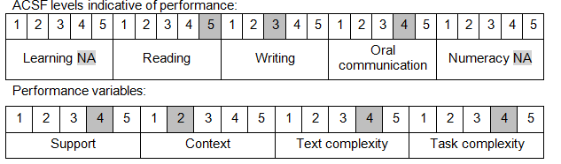

Further information on ACSF and the foundation skills underpinning this unit can be found in the Foundation Skills Guide on the GSA website.

Unit Mapping Information
This unit supersedes and is equivalent to DEFPR301B Identify material suitable for publication within Defence.

Links
Companion Volume implementation guides are found in VETNet - https://vetnet.gov.au/Pages/TrainingDocs.aspx?q=6bdbab1e-11ed-4bc9-9cba-9e1a55d4e4a9
Companion Volume implementation guides are found in VETNet - https://vetnet.gov.au/Pages/TrainingDocs.aspx?q=6bdbab1e-11ed-4bc9-9cba-9e1a55d4e4a9
Companion Volume implementation guides are found in VETNet - https://vetnet.gov.au/Pages/TrainingDocs.aspx?q=6bdbab1e-11ed-4bc9-9cba-9e1a55d4e4a9

