DEFGEN014 Act as a range safety officer on a permanent range
Release: 1

DEFGEN014 Act as a range safety officer on a permanent range

Modification History
Release | Comments
1 | This unit was released in DEF Defence Training Package release 1.0 and meets the Standards for Training Packages.  This unit supersedes and is equivalent to DEFCM118B Act as a range safety officer on a permanent range.  - Unit code updated  - Content and formatting updated to comply with the new standards  - All PC transitioned from passive to active voice  - PC 1.2 removed

Application
This unit describes the skills required to perform the duties of a range safety officer during the conduct of range practices on permanent ranges. Supervising safety on a permanent range includes safe handling and operation of weapons and ammunition for which the range safety officer has been assessed as qualified to operate.
Range practices are potentially high-risk activities, consequently applying, implementing and supervising safety precautions underpins all aspects of this competency. Ranges may include:
- 25 metre and 100 metre open ranges
- classification range
- mobile training range
- standard 25 metre range
- static mechanical range
- weapons training simulation system

This unit applies to Defence personnel required to perform the duties of a range safety officer, including butts or firing point supervisor, during the conduct of range practices on permanent ranges within a Defence working environment.
The skills and knowledge described in this unit must be applied within the legislative, regulatory and policy environment in which they are carried out. Organisational policies and procedures must be consulted and adhered to.
Those undertaking this unit would work independently, under indirect supervision, use discretion and judgement, and take responsibility for the quality of their outputs. They would perform routine tasks in a range of highly unpredictable contexts
No licensing, legislative or certification requirements apply to unit at the time of publication.

Competency Field
General

Elements and Performance Criteria
ELEMENTS | PERFORMANCE CRITERIA
Elements describe the essential outcomes | Performance criteria describe the performance needed to demonstrate achievement of the element. Where bold italicised text is used, further information is detailed in the range of conditions section.
1. Prepare for range practices | 1.1 Identify and apply relevant range regulations, WHS requirements and safety precautions.  1.2 Employ relevant control measures.  1.3 Complete administrative requirements.
2. Supervise safety on a range | 2.1 Monitor range to ensure a safe environment.  2.2 Maintain communications with range supervisor.  2.3 Identify unsafe practices and apply corrections.  2.4 Manage incidents in accordance with instructions from supervisor and range regulations.
3. Finalise a range practice | 3.1 Refurbish ranges.  3.2 Complete post range practice administration.

Foundation Skills
The foundation skills demands of this unit have been mapped for alignment with the Australian Core Skills Framework (ACSF). The following tables outline the performance levels indicated for successful attainment of the unit.

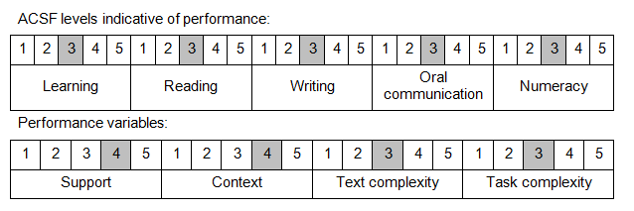

Further information on ACSF and the foundation skills underpinning this unit can be found in the Foundation Skills Guide on the GSA website.

Unit Mapping Information
This unit supersedes and is equivalent to DEFCM118B Act as a range safety officer on a permanent range.

Links
Companion Volume implementation guides are found in VETNet - https://vetnet.gov.au/Pages/TrainingDocs.aspx?q=6bdbab1e-11ed-4bc9-9cba-9e1a55d4e4a9
Companion Volume implementation guides are found in VETNet - https://vetnet.gov.au/Pages/TrainingDocs.aspx?q=6bdbab1e-11ed-4bc9-9cba-9e1a55d4e4a9
Companion Volume implementation guides are found in VETNet - https://vetnet.gov.au/Pages/TrainingDocs.aspx?q=6bdbab1e-11ed-4bc9-9cba-9e1a55d4e4a9

