DEFGEN013 Provide Initial Response to Combat Casualty
Release: 1

DEFGEN013 Provide Initial Response to Combat Casualty

Modification History
Release | Comments
1 | This unit was released in DEF Defence Training Package release 1.0 and meets the Standards for Training Packages.

Application
This unit describes the skills required to provide the first response to a combat casualty.
This unit was developed for military personnel within an operational zone but may be relevant to others working in this field.
The skills and knowledge described in this unit must be applied within the legislative, regulatory and policy environment in which they are carried out. Organisational policies and procedures must be consulted and adhered to.
Those undertaking this unit would work independently and as part of a team, would use discretion and judgement, and take responsibility for the quality of their outputs. They would perform complex tasks, in a range of unpredictable and sometimes hostile contexts.
No licensing, legislative or certification requirements apply to unit at the time of publication.

Competency Field
General

Elements and Performance Criteria
ELEMENTS | PERFORMANCE CRITERIA
Elements describe the essential outcomes | Performance criteria describe the performance needed to demonstrate achievement of the element. Where bold italicised text is used, further information is detailed in the range of conditions section.
1. Assess casualty scene | 1.1 Identify, assess and manage immediate and ongoing hazards to health and safety of self and others.  1.2 Assess casualty’s condition to determine appropriate response and need for assistance.  1.3 Communicate support requirements.
2. Initiate response to casualty’s condition | 2.1 Communicate with the casualty to provide reassurance.  2.2 Provide initial response to address casualty’s condition in accordance with organisational procedures utilising available resources/equipment.  2.3 Document casualty’s condition and treatment.  2.4 Prepare the casualty for evacuation.  2.5 Monitor casualty’s condition and undertake ongoing response.
3. Conclude the response | 3.1 Conduct hand over to higher qualified medical responders and assist as required.  3.2 Participate in debriefing/evaluation to improve future responses.

Foundation Skills
The foundation skills demands of this unit have been mapped for alignment with the Australian Core Skills Framework (ACSF). The following tables outline the performance levels indicated for successful attainment of the unit.
ACSF levels indicitive of performance:
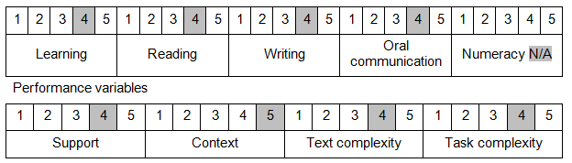

Further information on ACSF and the foundation skills underpinning this unit can be found in the Foundation Skills Guide on the GSA website.

Unit Mapping Information
No equivalent unit.

Links
Companion Volume implementation guides are found in VETNet - https://vetnet.gov.au/Pages/TrainingDocs.aspx?q=6bdbab1e-11ed-4bc9-9cba-9e1a55d4e4a9
Companion Volume implementation guides are found in VETNet - https://vetnet.gov.au/Pages/TrainingDocs.aspx?q=6bdbab1e-11ed-4bc9-9cba-9e1a55d4e4a9
Companion Volume implementation guides are found in VETNet - https://vetnet.gov.au/Pages/TrainingDocs.aspx?q=6bdbab1e-11ed-4bc9-9cba-9e1a55d4e4a9

