DEFFOR009 Give evidence of electronic media crime
Release: 1

DEFFOR009 Give evidence of electronic media crime

Modification History
Release | Comments
1 | This unit was released in DEF Defence Training Package release 1.0 and meets the Standards for Training Packages.

Application
This unit describes the skills required to give evidence as an electronic forensics expert witness in legal proceedings. The unit includes preparation for proceedings, presenting evidence and following up on outcomes of proceedings. Proceedings may be to criminal, coronial, civil or military courts; Defence or workers’ compensation tribunals; human rights, equal opportunity or royal commissions; administrative reviews or parliamentary hearings.
This unit applies to those working in the gathering and analysis of electronic information.
The skills and knowledge described in this unit must be applied within the legislative, regulatory and policy environment in which they are carried out. Organisational policies and procedures must be consulted and adhered to, particularly those relating to WHS and the search and seizure of electronic evidence.
Those undertaking this unit would work independently, with minimal supervision, while performing complex tasks, including making complex judgements. They would use discretion and judgement and take responsibility for the quality of their outputs.
No licensing, legislative or certification requirements apply to this unit at the time of publication.

Competency Field
Electronic Forensics

Elements and Performance Criteria
ELEMENTS | PERFORMANCE CRITERIA
Elements describe the essential outcomes | Performance criteria describe the performance needed to demonstrate achievement of the element. Where bold italicised text is used, further information is detailed in the range of conditions section.
1. Prepare for legal proceedings | 1.1 Confirm arrangements for role and involvement in legal proceedings.  1.2 Prepare documents and other exhibits.  1.3 Identify precedents relevant to the procedures.  1.4 Provide assistance to counsel as required.
2. Present expert evidence | 2.1 Apply rules of evidence relevant to the jurisdiction.  2.2 Translate technical practices and concepts into non-technical language, with explanations of technologies involved.  2.3 Present evidence in a clear, concise and articulate manner.  2.4 Provide considered expert evidence consistent with relevant qualifications and expertise in the area of electronic forensics.
3. Monitor and follow up the outcomes of legal proceedings | 3.1 Note and file the outcomes of proceedings and complete reports where required.  3.2 Note and action feedback from counsel and/or legal authority and comments by deciding authority.  3.3 Review outcomes of proceedings to ensure knowledge of trends and precedents is current.  3.4 Recommend changes to organisational policy and proceedings arising from rulings and decisions.

Foundation Skills
The foundation skills demands of this unit have been mapped for alignment with the Australian Core Skills Framework (ACSF). The following tables outline the performance levels indicated for successful attainment of the unit.
ACSF levels indicative of performance:
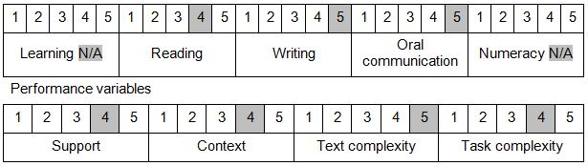

Further information on ACSF and the foundation skills underpinning this unit can be found in the Foundation Skills Guide on the GSA website.

Unit Mapping Information
No equivalent unit.

Links
Companion Volume implementation guides are found in VETNet - https://vetnet.gov.au/Pages/TrainingDocs.aspx?q=6bdbab1e-11ed-4bc9-9cba-9e1a55d4e4a9
Companion Volume implementation guides are found in VETNet - https://vetnet.gov.au/Pages/TrainingDocs.aspx?q=6bdbab1e-11ed-4bc9-9cba-9e1a55d4e4a9
Companion Volume implementation guides are found in VETNet - https://vetnet.gov.au/Pages/TrainingDocs.aspx?q=6bdbab1e-11ed-4bc9-9cba-9e1a55d4e4a9

