DEFFOR008 Detect, record and collect electronic evidence
Release: 1

DEFFOR008 Detect, record and collect electronic evidence

Modification History
Release | Comments
1 | This unit was released in DEF Defence Training Package release 1.0 and meets the Standards for Training Packages.

Application
This unit describes the skills required to conduct activities involved in the detection, recording and collection of electronic evidence prior to laboratory examination. It requires the individual to detect, record, collect and package both digital and analogue recording and communications equipment including hard drives, recording media, flash drives, tape drives, random-access memory (RAM), read-only memory (ROM), basic input/output system (BIOS) and other peripherals.
This unit applies to those working in the gathering and analysis of electronic information.
The skills and knowledge described in this unit must be applied within the legislative, regulatory and policy environment in which they are carried out. Organisational policies and procedures must be consulted and adhered to, particularly those relating to WHS and the search for and seizure of electronic evidence.
Those undertaking this unit would work independently, with minimal supervision, while performing complex tasks, including making complex judgements. They would use discretion and judgement and take responsibility for the quality of their outputs.
No licensing, legislative or certification requirements apply to this unit at the time of publication.

Competency Field
Electronic Forensics

Elements and Performance Criteria
ELEMENTS | PERFORMANCE CRITERIA
Elements describe the essential outcomes | Performance criteria describe the performance needed to demonstrate achievement of the element. Where bold italicised text is used, further information is detailed in the range of conditions section.
1. Detect and record electronic evidence | 1.1 Detect electronic evidence using observational techniques and technological methods.  1.2 Record electronic evidence prior to examination.  1.3 Document the recorded electronic evidence.
2. Collect electronic evidence | 2.1 Collect electronic evidence by handpicking or removing media from machines to prevent contamination or loss.  2.2 Ensure that collected electronic evidence is sufficient in quantity, where possible, to allow all potential examinations/analyses to be carried out.
3. Package electronic evidence | 3.1 Package and store items to maintain continuity and prevent degradation or contamination.  3.2 Package electronic evidence.  3.3 Enter details of electronic evidence collected in case notes and, where appropriate, in the exhibit register to maintain continuity.

Foundation Skills
The foundation skills demands of this unit have been mapped for alignment with the Australian Core Skills Framework (ACSF). The following tables outline the performance levels indicated for successful attainment of the unit.
ACSF levels indicative of performance:
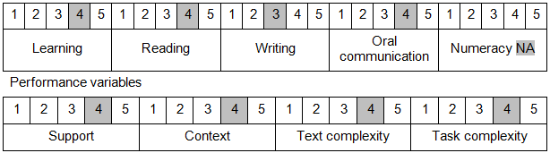

Further information on ACSF and the foundation skills underpinning this unit can be found in the Foundation Skills Guide on the GSA website.

Unit Mapping Information
No equivalent unit.

Links
Companion Volume implementation guides are found in VETNet - https://vetnet.gov.au/Pages/TrainingDocs.aspx?q=6bdbab1e-11ed-4bc9-9cba-9e1a55d4e4a9
Companion Volume implementation guides are found in VETNet - https://vetnet.gov.au/Pages/TrainingDocs.aspx?q=6bdbab1e-11ed-4bc9-9cba-9e1a55d4e4a9
Companion Volume implementation guides are found in VETNet - https://vetnet.gov.au/Pages/TrainingDocs.aspx?q=6bdbab1e-11ed-4bc9-9cba-9e1a55d4e4a9

