DEFFOR005 Compile and submit electronic media forensic documentation
Release: 1

DEFFOR005 Compile and submit electronic media forensic documentation

Modification History
Release | Comments
1 | This unit was released in DEF Defence Training Package release 1.0 and meets the Standards for Training Packages.

Application
This unit describes the skills required to compile and submit documentation relating to electronic forensic investigation. It includes completing forms, compiling reports and returns, compiling statements, affidavits and statutory declarations, compiling statements of evidence, compiling exhibit registers and logs, and completing the day-to-day paperwork required in the area of electronic forensics.
This unit applies to those working in the gathering and analysis of electronic information.
The skills and knowledge described in this unit must be applied within the legislative, regulatory and policy environment in which they are carried out. Organisational policies and procedures must be consulted and adhered to, particularly those relating to WHS and the completion and submission of documentation relating to electronic forensic investigations.
Those undertaking this unit would work independently or as part of a team, under indirect supervision, while performing routine tasks in a range of contexts. They must be able to use discretion and judgement and take responsibility for the quality of their outputs.
No licensing, legislative or certification requirements apply to unit at the time of publication.

Competency Field
Electronic Forensics

Elements and Performance Criteria
ELEMENTS | PERFORMANCE CRITERIA
Elements describe the essential outcomes | Performance criteria describe the performance needed to demonstrate achievement of the element. Where bold italicised text is used, further information is detailed in the range of conditions section.
1. Maintain documentation | 1.1 Compile and maintain accurate, complete, legible and comprehensible documentation including notes. and associated records relating to cases/jobs/tasks.  1.2 Ensure appropriate handling of documentation to the security level of the document concerned.
2. Handle documentation | 2.1 Submit documentation such as notes, reports and associated records.  2.2 Store/archive notes and associated records at the conclusion of proceedings.

Foundation Skills
The foundation skills demands of this unit have been mapped for alignment with the Australian Core Skills Framework (ACSF). The following tables outline the performance levels indicated for successful attainment of the unit.
ACSF levels indicative of performance:
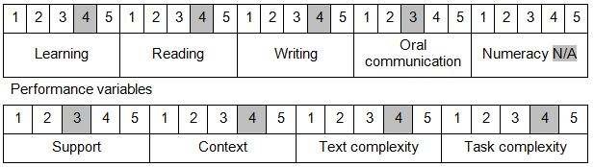

Further information on ACSF and the foundation skills underpinning this unit can be found in the Foundation Skills Guide on the GSA website.

Unit Mapping Information
No equivalent unit.

Links
Companion Volume implementation guides are found in VETNet - https://vetnet.gov.au/Pages/TrainingDocs.aspx?q=6bdbab1e-11ed-4bc9-9cba-9e1a55d4e4a9
Companion Volume implementation guides are found in VETNet - https://vetnet.gov.au/Pages/TrainingDocs.aspx?q=6bdbab1e-11ed-4bc9-9cba-9e1a55d4e4a9
Companion Volume implementation guides are found in VETNet - https://vetnet.gov.au/Pages/TrainingDocs.aspx?q=6bdbab1e-11ed-4bc9-9cba-9e1a55d4e4a9

