DEFFOR002 Conduct initial electronic investigation
Release: 1

DEFFOR002 Conduct initial electronic investigation

Modification History
Release | Comments
1 | This unit was released in DEF Defence Training Package release 1.0 and meets the Standards for Training Packages.

Application
This unit describes the skills required to gather and collate information and obvious and accessible electronic evidence from the scene of an incident and identify potential witnesses. In the context of this unit, electronic evidence may include computer hard drives, recording media, flash drives, tape drives or digital and analogue recording and communications equipment. It includes maintaining the chain of evidential record.
This unit applies to those working in the gathering and analysis of electronic information.
The skills and knowledge described in this unit must be applied within the legislative, regulatory and policy environment in which they are carried out. Organisational policies and procedures must be consulted and adhered to, particularly those relating to WHS, recording details of witnesses, and the search and seizure of electronic evidence.
Those undertaking this unit would work independently or as part of a team, under indirect supervision, while performing complex tasks in a broad range of contexts. They must be able to use discretion and judgement and take responsibility for the quality of their outputs.
No licensing, legislative or certification requirements apply to this unit at the time of publication.

Competency Field
Electronic Forensics

Elements and Performance Criteria
ELEMENTS | PERFORMANCE CRITERIA
Elements describe the essential outcomes | Performance criteria describe the performance needed to demonstrate achievement of the element. Where bold italicised text is used, further information is detailed in the range of conditions section.
1. Conduct initial assessment of scene | 1.1 Assess the scene.  1.2 Establish communication with the senior investigating officer and maintain liaison throughout the investigation.  1.3 Ascertain the circumstances surrounding the scene through visual assessment and reports from other personnel.  1.4 Define/redefine the scene boundaries as required to preserve physical evidence for collection.  1.5 Locate obvious and accessible electronic evidence and, where appropriate, protect from possible contamination.
2. Control integrity of scene | 2.1 Establish and maintain appropriate arrangements for scene access and egress.  2.2 Identify and access additional resources required to secure incident scene.
3. Examine scene | 3.1 Instigate an appropriate search pattern to ensure all electronic evidence is located and preserved.  3.2 Record details of the scene and types of electronic equipment and media.  3.3 Locate, collect, package, label and store electronic evidence to ensure preservation for further examination.  3.4 Maintain a log of all evidence.
4. Identify potential witnesses and record initial statements | 4.1 Identify and record names and contact details of potential witnesses.  4.2 Record initial statement using appropriate recording practices.

Foundation Skills
The foundation skills demands of this unit have been mapped for alignment with the Australian Core Skills Framework (ACSF). The following tables outline the performance levels indicated for successful attainment of the unit.
ACSF levels indicative of performance:
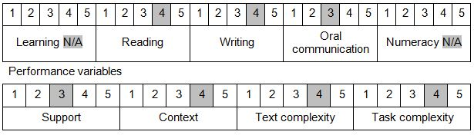

Further information on ACSF and the foundation skills underpinning this unit can be found in the Foundation Skills Guide on the GSA website.

Unit Mapping Information
No equivalent unit.

Links
Companion Volume implementation guides are found in VETNet - https://vetnet.gov.au/Pages/TrainingDocs.aspx?q=6bdbab1e-11ed-4bc9-9cba-9e1a55d4e4a9
Companion Volume implementation guides are found in VETNet - https://vetnet.gov.au/Pages/TrainingDocs.aspx?q=6bdbab1e-11ed-4bc9-9cba-9e1a55d4e4a9
Companion Volume implementation guides are found in VETNet - https://vetnet.gov.au/Pages/TrainingDocs.aspx?q=6bdbab1e-11ed-4bc9-9cba-9e1a55d4e4a9

