DEFEXO011 Refurbish explosives packaging
Release: 1

DEFEXO011 Refurbish explosives packaging

Modification History
Release | Comments
1 | This unit was released in DEF Defence Training Package release 1.0 and meets the Standards for Training Packages.  This unit supersedes and is equivalent to DEFEO521A Refurbish explosives packaging.  - Unit code updated  - Content and formatting updated to comply with the new standards  - All PC transitioned from passive to active voice  - PC 1.2 removed  - PC 2.2 and 3.1 reworded

Application
This unit describes the skills required to refurbish explosives packaging. The unit requires the individual to inspect the packaging to determine whether it can be refurbished, refurbish the packaging and maintain a range of documentation.
This unit applies to those required to prepare for and refurbish explosives packaging following deterioration or damage of the packaging through handling.
The skills and knowledge described in this unit must be applied within the legislative, regulatory and policy environment in which they are carried out. Organisational policies and procedures must be consulted and adhered to.
Those undertaking this unit would work as individuals and as part of a team, under direct and/or indirect supervision, use discretion and judgement, and take responsibility for the quality of their output. They would perform routine tasks in a range of contexts.
No licensing, legislative or certification requirements apply to unit at the time of publication.

Competency Field
Explosive ordnance

Elements and Performance Criteria
ELEMENTS | PERFORMANCE CRITERIA
Elements describe the essential outcomes | Performance criteria describe the performance needed to demonstrate achievement of the element. Where bold italicised text is used, further information is detailed in the range of conditions section.
1. Prepare for refurbishment | 1.1 Identify requirement for refurbishing of packaging from work requests/instructions.  1.2 Identify, acquire and prepare technical references, tools, equipment and consumables required for maintenance.  1.3 Inspect explosives packaging to confirm that it is free from explosives.
2. Refurbish explosive packaging | 2.1 Inspect explosives packaging to ensure it is capable of being refurbished.  2.2 Return explosives packaging to serviceable state.
3. Finalise reconditioning procedures | 3.1 Return explosives packaging to storage or transport condition.  3.2 Conduct housekeeping procedures.  3.3 Maintain documentation and records.

Foundation Skills
The foundation skills demands of this unit have been mapped for alignment with the Australian Core Skills Framework (ACSF). The following tables outline the performance levels indicated for successful attainment of the unit.

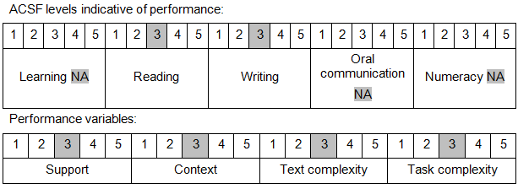

Further information on ACSF and the foundation skills underpinning this unit can be found in the Foundation Skills Guide on the GSA website.

Unit Mapping Information
This unit supersedes and is equivalent to DEFEO521A Refurbish explosives packaging.

Links
Companion Volume implementation guides are found in VETNet - https://vetnet.gov.au/Pages/TrainingDocs.aspx?q=6bdbab1e-11ed-4bc9-9cba-9e1a55d4e4a9
Companion Volume implementation guides are found in VETNet - https://vetnet.gov.au/Pages/TrainingDocs.aspx?q=6bdbab1e-11ed-4bc9-9cba-9e1a55d4e4a9
Companion Volume implementation guides are found in VETNet - https://vetnet.gov.au/Pages/TrainingDocs.aspx?q=6bdbab1e-11ed-4bc9-9cba-9e1a55d4e4a9

