DEFEXO010 Conduct explosives packaging inspection
Release: 1

DEFEXO010 Conduct explosives packaging inspection

Modification History
Release | Comments
1 | This unit was released in DEF Defence Training Package release 1.0 and meets the Standards for Training Packages.  This unit supersedes and is equivalent to DEFEO503C Conduct explosives packaging inspection.  - Unit code updated  - Content and formatting updated to comply with the new standards  - All PC transitioned from passive to active voice  - PC 1.2 removed  - PC 3.1 reworded  - Element 1 one new PC

Application
This unit describes the skills required to conduct an inspection of explosives packaging and to process the packaging for further action that may be required. Processing the packaging is subject to the outcomes of the inspection and may result in damaged or defective packaging being rejected, disposed of, returned to the manufacturer or sent for maintenance.
This unit applies to those required to conduct an inspection of explosive packaging and to process the packaging for further action that may be required.
The skills and knowledge described in this unit must be applied within the legislative, regulatory and policy environment in which they are carried out. Organisational policies and procedures must be consulted and adhered to.
Those undertaking this unit would work independently and as part of a team, under direct and/or indirect supervision, use discretion and judgement, and take responsibility for the quality of their output. They would perform routine tasks in a range of contexts.
No licensing, legislative or certification requirements apply to unit at the time of publication.

Competency Field
Explosive ordnance

Elements and Performance Criteria
ELEMENTS | PERFORMANCE CRITERIA
Elements describe the essential outcomes | Performance criteria describe the performance needed to demonstrate achievement of the element. Where bold italicised text is used, further information is detailed in the range of conditions section.
1. Prepare for inspection | 1.1 Identify requirement for explosives packaging inspection from work requests and or instructions.  1.2 Identify, acquire and prepare technical references, tools and equipment required for the inspection.  1.3 Identify, acquire, account for, move or pre-position packaging in preparation for inspection.  1.4 Interpret emergency procedures and apply contingency plans.
2. Inspect explosive packaging | 2.1 Inspect packaging in a logical set sequence to ensure that defects or damage are not overlooked, in accordance with technical specifications.  2.2 Identify and record damage or other defects.
3. Carry out post inspection procedures | 3.1 Return explosive packaging to storage or transport condition.  3.2 Maintain documentation and records.

Foundation Skills
The foundation skills demands of this unit have been mapped for alignment with the Australian Core Skills Framework (ACSF). The following tables outline the performance levels indicated for successful attainment of the unit.

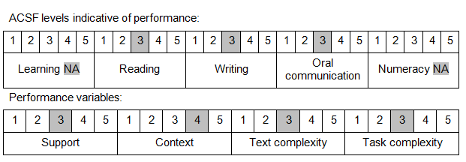

Further information on ACSF and the foundation skills underpinning this unit can be found in the Foundation Skills Guide on the GSA website.

Unit Mapping Information
This unit supersedes and is equivalent to DEFEO503C Conduct explosives packaging inspection.

Links
Companion Volume implementation guides are found in VETNet - https://vetnet.gov.au/Pages/TrainingDocs.aspx?q=6bdbab1e-11ed-4bc9-9cba-9e1a55d4e4a9
Companion Volume implementation guides are found in VETNet - https://vetnet.gov.au/Pages/TrainingDocs.aspx?q=6bdbab1e-11ed-4bc9-9cba-9e1a55d4e4a9
Companion Volume implementation guides are found in VETNet - https://vetnet.gov.au/Pages/TrainingDocs.aspx?q=6bdbab1e-11ed-4bc9-9cba-9e1a55d4e4a9

