CSCTRA002 Operate security vehicles
Release: 1

CSCTRA002 Operate security vehicles

Modification History
Release | Comments
1 | This unit was released in CSC Correctional Services Training Package release 1.0 and meets the Standards for Training Packages.  This unit supersedes and is equivalent to CSCTRA202A Operate security vehicles.

Application
This unit describes the skills required to maintain transport vehicles and drive to and from assignments.
This unit applies to those operating motor vehicles used for security purposes.
The skills and knowledge described in this unit must be applied within the legislative, regulatory and policy environment in which they are carried out. Organisational policies and procedures must be consulted and adhered to, particularly those related to operation of security vehicles.
Those undertaking this unit work in coordinated teams with moderate support required. The role requires simply inferencing, communication and navigational skills.
No licensing, legislative or certification requirements apply to unit at the time of publication.

Competency Field
Transport and escort

Elements and Performance Criteria
ELEMENTS | PERFORMANCE CRITERIA
Elements describe the essential outcomes | Performance criteria describe the performance needed to demonstrate achievement of the element. Where bold italicised text is used, further information is detailed in the range of conditions section.
1. Maintain vehicle | 1.1 Check condition of vehicle regularly according to procedures and manufacturer specifications for care and maintenance.  1.2 Identify faults and malfunctions and report these according to procedures.  1.3 Attend to routine vehicle requirements in a timely manner and according to procedures.
2. Drive to and from assignment | 2.1 Drive vehicles according to road and traffic statutes and regulations.  2.2 Organise the journey to follow the most direct route to or from the assignment chosen, having regard to traffic and road conditions.  2.3 Select the quickest route to the scene of emergency or alarm, based on traffic and road conditions.  2.4 Drive vehicles in a manner that minimises risk of injury to self and others at all times.

Foundation Skills
The foundation skills demands of this unit have been mapped for alignment with the Australian Core Skills Framework (ACSF). The following tables outline the performance levels indicated for successful attainment of the unit.
ACSF levels indicative of performance:
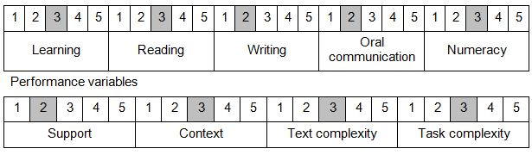

Further information on ACSF and the foundation skills underpinning this unit can be found in the Foundation Skills Guide http://www.govskills.com.au/guides/correctional-services/foundation-skills-guide on the GSA website.

Unit Mapping Information
Supersedes and is equivalent to CSCTRA202A Operate security vehicles.

Links
Companion Volume implementation guides are found in VETNet - https://vetnet.gov.au/Pages/TrainingDocs.aspx?q=114e25cd-3a2c-4490-baae-47d68dcd2fde
Companion Volume implementation guides are found in VETNet - https://vetnet.gov.au/Pages/TrainingDocs.aspx?q=114e25cd-3a2c-4490-baae-47d68dcd2fde
Companion Volume implementation guides are found in VETNet - https://vetnet.gov.au/Pages/TrainingDocs.aspx?q=114e25cd-3a2c-4490-baae-47d68dcd2fde
Companion Volume implementation guides are found in VETNet - https://vetnet.gov.au/Pages/TrainingDocs.aspx?q=114e25cd-3a2c-4490-baae-47d68dcd2fde

