CSCSAS006 Respond to medical emergencies
Release: 1

CSCSAS006 Respond to medical emergencies

Modification History
Release | Comments
1 | This unit was released in CSC Correctional Services Training Package release 1.0 and meets the Standards for Training Packages.  This unit supersedes and is equivalent to CSCSAS206A Respond to medical emergencies.

Application
This unit describes the skills required to provide an immediate response to medical emergencies and preserve the incident site.

This unit applies to those working in detention centres, correctional centres or prisons, community corrections offices, justice administration offices and on work sites where detainees, prisoners or offenders are under statutory supervision.

The skills and knowledge described in this unit must be applied within the legislative, regulatory and policy environment in which they are carried out. Organisational policies and procedures must be consulted and adhered to, particularly those related to working with offenders and detainees and administering first aid.

Those undertaking this unit work with moderate support at all times and undertake tasks with a limited number of familiar steps.

No licensing, legislative or certification requirements apply to unit at the time of publication.

Competency Field
Safety and security

Elements and Performance Criteria
ELEMENTS | PERFORMANCE CRITERIA
Elements describe the essential outcomes | Performance criteria describe the performance needed to demonstrate achievement of the element. Where bold italicised text is used, further information is detailed in the range of conditions section.
1. Provide an immediate response to urgent conditions | 1.1 Control any hazards and consider the safety of self, the casualty and others in all action taken.  1.2 Assess the casualty’s condition in line with established first aid principles.  1.3 Call for medical support according to the casualty’s condition, using appropriate alarm codes and responses.  1.4 Provide first aid management and monitor the casualty’s vital signs.  1.5 Record and report incidents and own response.  1.6 Participate in incident debriefing and counselling.
2. Supervise an incident site | 2.1 Assess the degree of risk and apply emergency procedures, considering the safety of self and others in all actions taken.  2.2 Maintain a calm and confident manner in all communication and actions.  2.3 Comply precisely with your organisation’s work health and safety (WHS) and infection control guidelines.  2.4 Call for specialist help according to the urgency of the situation.  2.5 Report all aspects of the incident and response accurately and according to the required process.

Foundation Skills
The foundation skills demands of this unit have been mapped for alignment with the Australian Core Skills Framework (ACSF). The following tables outline the performance levels indicated for successful attainment of the unit.

ACSF levels indicative of performance:
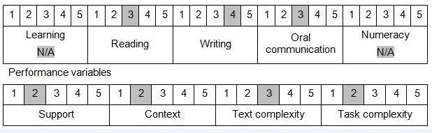

Further information on ACSF and the foundation skills underpinning this unit can be found in the Foundation Skills Guide http://www.govskills.com.au/guides/correctional-services/foundation-skills-guide on the GSA website.

Unit Mapping Information
Supersedes and is equivalent to CSCSAS206A Respond to medical emergencies.

Links
GSA website - http://www.govskills.com.au
CSC Foundations Skills Guide - http://www.govskills.com.au/guides/correctional-services/foundation-skills-guide
CSC Knowledge Guide - http://www.govskills.com.au/guides/correctional-services/knowledge-guide
CSC Implementation Guide - http://www.govskills.com.au/guides/correctional-services/implementation-guide

