CSCORG016 Coordinate resource allocation and usage
Release: 1

CSCORG016 Coordinate resource allocation and usage

Modification History
Release | Comments
1 | This unit was released in CSC Correctional Services Training Package release 1.0 and meets the Standards for Training Packages.  This unit supersedes and is equivalent to CSCORG503A Coordinate resource allocation and usage.

Application
This unit describes the skills required to allocate resources to achieve results; and monitor, evaluate and report on resource usage.
This unit applies to those working in generalist and specialist roles from a range of occupational areas where responsibility for resource allocation is required.
The skills and knowledge described in this unit must be applied within the legislative, regulatory and policy environment in which they are carried out. Organisational policies and procedures must be consulted and adhered to, particularly those related to use of resources.
Those undertaking this unit work autonomously, occasionally accessing and evaluating support from a broad range of sources. The role requires ICT, analysis and organisation skills.
No licensing, legislative or certification requirements apply to unit at the time of publication.

Competency Field
Organisational administration and management

Elements and Performance Criteria
ELEMENTS | PERFORMANCE CRITERIA
Elements describe the essential outcomes | Performance criteria describe the performance needed to demonstrate achievement of the element. Where bold italicised text is used, further information is detailed in the range of conditions section.
1. Allocate available resources to achieve results | 1.1 Identify resource requirements based on assessment of current workloads and staff needs.  1.2 Allocate resources to enable achievement of work unit objectives.  1.3 Acquire and allocate resources within limits of individual delegation or refer to others.
2. Monitor and evaluate resource usage | 2.1 Implement systems to enable timely and accurate monitoring and evaluation of resource usage against targets and organisational standards.  2.2 Maintain records of resource allocation and usage.  2.3 Identify and address resource usage issues against feedback, and review information.  2.4 Allocate replacement or additional resources as required.
3. Report on resource usage | 3.1 Report resource usage in an appropriate format and on a regular basis.  3.2 Complete reports to indicate the level of performance achieved and any follow-up action required.  3.3 Apply appropriate technology to resource management systems.

Foundation Skills
The foundation skills demands of this unit have been mapped for alignment with the Australian Core Skills Framework (ACSF). The following tables outline the performance levels indicated for successful attainment of the unit.
ACSF levels indicative of performance:
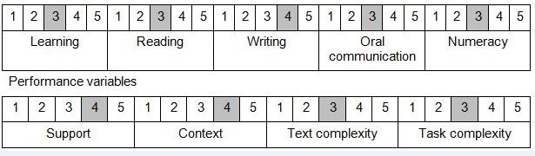

Further information on ACSF and the foundation skills underpinning this unit can be found in the Foundation Skills Guide http://www.govskills.com.au/guides/correctional-services/foundation-skills-guide on the GSA website.

Unit Mapping Information
Supersedes and is equivalent to CSCORG503A Coordinate resource allocation and usage.

Links
Companion Volume implementation guides are found in VETNet - https://vetnet.gov.au/Pages/TrainingDocs.aspx?q=114e25cd-3a2c-4490-baae-47d68dcd2fde
Companion Volume implementation guides are found in VETNet - https://vetnet.gov.au/Pages/TrainingDocs.aspx?q=114e25cd-3a2c-4490-baae-47d68dcd2fde
Companion Volume implementation guides are found in VETNet - https://vetnet.gov.au/Pages/TrainingDocs.aspx?q=114e25cd-3a2c-4490-baae-47d68dcd2fde
Companion Volume implementation guides are found in VETNet - https://vetnet.gov.au/Pages/TrainingDocs.aspx?q=114e25cd-3a2c-4490-baae-47d68dcd2fde

