CSCORG015 Represent and promote the organisation
Release: 1

CSCORG015 Represent and promote the organisation

Modification History
Release | Comments
1 | This unit was released in CSC Correctional Services Training Package release 1.0 and meets the Standards for Training Packages.  This unit supersedes and is equivalent to CSCORG502A Represent and promote the organisation.

Application
This unit describes the skills required to promote an organisation, liaise and negotiate to achieve outcomes, and build and maintain networks.
This unit applies to those working in a management role within correctional services, but with some contextualisation may apply to workers in a range of occupational areas.
The skills and knowledge described in this unit must be applied within the legislative, regulatory and policy environment in which they are carried out. Organisational policies and procedures must be consulted and adhered to, particularly those related to sharing of sensitive information.
Those undertaking this unit work autonomously, occasionally accessing and evaluating support from a broad range of sources. The role requires critical reflection and high level communication skills.
No licensing, legislative or certification requirements apply to unit at the time of publication.

Competency Field
Organisational administration and management

Elements and Performance Criteria
ELEMENTS | PERFORMANCE CRITERIA
Elements describe the essential outcomes | Performance criteria describe the performance needed to demonstrate achievement of the element. Where bold italicised text is used, further information is detailed in the range of conditions section.
1. Promote the organisation | 1.1 Use a range of strategies to promote a positive image of the organisation at every available opportunity.  1.2 Communicate issues, policies and practices effectively to a range of audiences in writing and orally.  1.3 Develop and distribute authoritative and specialist advice within the area of responsibility.
2. Influence others | 2.1 Design interpersonal communication to meet the needs of the audience and the objectives of the presentation.  2.2 Convey points of view and information that contribute to consensus in a positive manner.
3. Liaise and negotiate to achieve outcomes | 3.1 Negotiate effectively to achieve the determined objectives of the communication.  3.2 Use conflict-resolution techniques effectively to ensure positive outcomes for participants.  3.3 Identify and involve appropriate key people in achieving outcomes.
4. Build and maintain networks | 4.1 Develop and maintain networks and work relationships to provide identifiable benefits to organisation, clients and self.  4.2 Identify and maintain contact with formal and informal networks to assist in achieving determined outcomes.  4.3 Apply appropriate time and effort in establishing and maintaining networks to ensure their effectiveness in meeting determined outcomes.

Foundation Skills
The foundation skills demands of this unit have been mapped for alignment with the Australian Core Skills Framework (ACSF). The following tables outline the performance levels indicated for successful attainment of the unit.
ACSF levels indicative of performance:
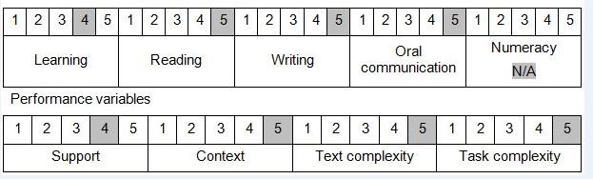

Further information on ACSF and the foundation skills underpinning this unit can be found in the Foundation Skills Guide http://www.govskills.com.au/guides/correctional-services/foundation-skills-guide on the GSA website.

Unit Mapping Information
Supersedes and is equivalent to CSCORG502A Represent and promote the organisation.

Links
Companion Volume implementation guides are found in VETNet - https://vetnet.gov.au/Pages/TrainingDocs.aspx?q=114e25cd-3a2c-4490-baae-47d68dcd2fde
Companion Volume implementation guides are found in VETNet - https://vetnet.gov.au/Pages/TrainingDocs.aspx?q=114e25cd-3a2c-4490-baae-47d68dcd2fde
Companion Volume implementation guides are found in VETNet - https://vetnet.gov.au/Pages/TrainingDocs.aspx?q=114e25cd-3a2c-4490-baae-47d68dcd2fde
Companion Volume implementation guides are found in VETNet - https://vetnet.gov.au/Pages/TrainingDocs.aspx?q=114e25cd-3a2c-4490-baae-47d68dcd2fde

