CSCORG006 Work effectively with culturally diverse offenders and colleagues
Release: 1

CSCORG006 Work effectively with culturally diverse offenders and colleagues

Modification History
Release | Comments
1 | This unit was released in CSC Correctional Services Training Package release 1.0 and meets the Standards for Training Packages.  This unit supersedes and is equivalent to CSCORG304 Work effectively with culturally diverse offenders and colleagues.  - PC 4.2 wording revised

Application
This unit describes the skills required to demonstrate cultural awareness in the workplace, communicate effectively with culturally diverse people and resolve cross-cultural misunderstandings.

This unit applies to those working in prisons, secure custodial centres, within the community and other contexts where working with detained persons is part of the work role. This unit describes skills for working effectively with both offenders and colleagues.

The skills and knowledge described in this unit must be applied within the legislative, regulatory and policy environment in which they are carried out. Organisational policies and procedures must be consulted and adhered to, particularly those related to equal opportunity.

Those undertaking this unit work independently, drawing upon regular support. The role requires communication, reflection and simple abstracting skills.

No licensing, legislative or certification requirements apply to unit at the time of publication.

Competency Field
Organisational administration and management

Elements and Performance Criteria
ELEMENTS | PERFORMANCE CRITERIA
Elements describe the essential outcomes | Performance criteria describe the performance needed to demonstrate achievement of the element. Where bold italicised text is used, further information is detailed in the range of conditions section.
1. Reflect cultural awareness in work practice | 1.1 Use culturally appropriate work practices to demonstrate awareness of culture as a factor in all human behaviour.  1.2 Use work practices that create a culturally and psychologically safe environment for all persons.  1.3 Review and modify work practices in consultation with persons from diverse cultural backgrounds.
2. Accept cultural diversity as a basis for effective workplace and professional relationships | 2.1 Show respect for cultural diversity in all communication and interactions with colleagues, visitors and offenders.  2.2 Use specific strategies to eliminate bias and discrimination in the workplace.  2.3 Contribute to the development of workplace and professional relationships based on acceptance of cultural diversity.
3. Communicate effectively with culturally diverse persons | 3.1 Use communication constructively to develop and maintain effective relationships and mutual trust.  3.2 Where language barriers exist, make efforts to communicate in the most effective way possible.  3.3 Seek assistance from interpreters or other persons as required.
4. Resolve cross-cultural misunderstandings | 4.1 Identify issues that may cause conflict.  4.2 Identify the impact of cultural differences on communication.  4.3 Resolve differences, taking account of cultural considerations.  4.4 Address any difficulties with appropriate people and seek assistance when required.

Foundation Skills
The foundation skills demands of this unit have been mapped for alignment with the Australian Core Skills Framework (ACSF). The following tables outline the performance levels indicated for successful attainment of the unit.

ACSF levels indicative of performance:
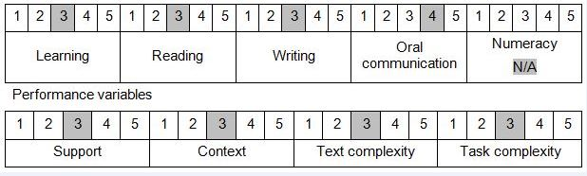

Further information on ACSF and the foundation skills underpinning this unit can be found in the Foundation Skills Guide http://www.govskills.com.au/guides/correctional-services/foundation-skills-guide on the GSA website.

Unit Mapping Information
Supersedes and is equivalent to CSCORG304 Work effectively with culturally diverse offenders and colleagues.

Links
GSA website - http://www.govskills.com.au
CSC Foundations Skills Guide - http://www.govskills.com.au/guides/correctional-services/foundation-skills-guide
CSC Knowledge Guide - http://www.govskills.com.au/guides/correctional-services/knowledge-guide
CSC Implementation Guide - http://www.govskills.com.au/guides/correctional-services/implementation-guide

