CSCOFM014 Supervise female offenders
Release: 1

CSCOFM014 Supervise female offenders

Modification History
Release | Comments
1 | This unit was released in CSC Correctional Services Training Package release 1.0 and meets the Standards for Training Packages.  This unit supersedes and is equivalent to CSCOFM311 Supervise female offenders.  - PC 2.2 wording revised

Application
This unit describes the skills required to supervise and support female offenders whilst maintaining a professional relationship and facilitating the offender’s behavioural self-awareness.
This unit applies to those working with female offenders in custody and in community programs. With contextualisation based on different organisation’s needs, it can apply to workers in juvenile detention, immigration detention or other contexts where working with female detained persons is part of the work role.
The skills and knowledge described in this unit must be applied within the legislative, regulatory and policy environment in which they are carried out. Organisational policies and procedures must be consulted and adhered to, particularly those related to interaction with offenders.
Those undertaking this unit work autonomously using support from mostly familiar resources. The role involves complex task organisation and analysis in a range of contexts that may be unfamiliar or unpredictable.
No licensing, legislative or certification requirements apply to unit at the time of publication.

Competency Field
Offender management

Elements and Performance Criteria
ELEMENTS | PERFORMANCE CRITERIA
Elements describe the essential outcomes | Performance criteria describe the performance needed to demonstrate achievement of the element. Where bold italicised text is used, further information is detailed in the range of conditions section.
1. Support female offenders in maintaining relationships | 1.1 Assist female offenders to maintain contact with family, friends and support networks.  1.2 Facilitate contact between female offenders and networks in the community.  1.3 Encourage female offenders to confidently and positively manage themselves and their relationships.  1.4 Provide support to female offenders in a manner that maintains the integrity of self-management and personal dignity.
2. Maintain professional relationship with female offenders | 2.1 Communicate with female offenders in a manner appropriate to the offenders’ needs and circumstances.  2.2 Develop and maintain supportive and appropriate relationships with female offenders and service agencies.  2.3 Respond positively, appropriately and consistently to female offenders’ requests and concerns.  2.4 Manage and maintain professional boundaries.
3. Facilitate offender’s behaviour self-awareness | 3.1 Establish and maintain acceptable boundaries of behaviour.  3.2 Provide feedback to female offenders to assist them to identify the impact of their behaviour on self and others.  3.3 Assist female offenders to identify unacceptable patterns of behaviour and negotiate change.  3.4 Provide positive reinforcement of acceptable behaviour and acknowledge progress toward change.  3.5 Utilise support networks to support changes in behaviour.
4. Provide supervision to female offenders | 4.1 Conduct interviews with female offenders.  4.2 Use communication strategies with female offenders to promote effective interaction.  4.3 Identify and use a range of communication styles to respect and reflect the diversity of the workplace and working with female offenders.  4.4 Observe female offenders’ routines and monitor changes and identify needs and potential risks.  4.5 Refer to specialist services where needs and risks are identified.

Foundation Skills
The foundation skills demands of this unit have been mapped for alignment with the Australian Core Skills Framework (ACSF). The following tables outline the performance levels indicated for successful attainment of the unit.
ACSF levels indicative of performance:
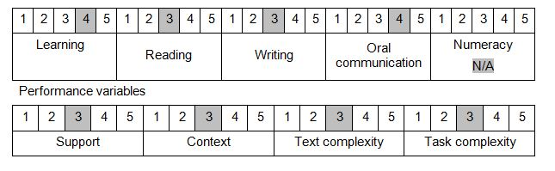

Further information on ACSF and the foundation skills underpinning this unit can be found in the Foundation Skills Guide http://www.govskills.com.au/guides/correctional-services/foundation-skills-guide on the GSA website.

Unit Mapping Information
Supersedes and is equivalent to CSCOFM311 Supervise female offenders.

Links
Companion Volume implementation guides are found in VETNet - https://vetnet.gov.au/Pages/TrainingDocs.aspx?q=114e25cd-3a2c-4490-baae-47d68dcd2fde
Companion Volume implementation guides are found in VETNet - https://vetnet.gov.au/Pages/TrainingDocs.aspx?q=114e25cd-3a2c-4490-baae-47d68dcd2fde
Companion Volume implementation guides are found in VETNet - https://vetnet.gov.au/Pages/TrainingDocs.aspx?q=114e25cd-3a2c-4490-baae-47d68dcd2fde
Companion Volume implementation guides are found in VETNet - https://vetnet.gov.au/Pages/TrainingDocs.aspx?q=114e25cd-3a2c-4490-baae-47d68dcd2fde

