CSCOFM013 Provide responsible care to people with a mental health problem and/or condition
Release: 1

CSCOFM013 Provide responsible care to people with a mental health problem and/or condition

Modification History
Release | Comments
1 | This unit was released in CSC Correctional Services Training Package release 1.0 and meets the Standards for Training Packages.  This unit supersedes and is equivalent to CSCOFM310 Provide responsible care to people with a mental health problem and or condition.  - PC 1.1 reworded for clarity  - PC 1.3 removed to Knowledge Evidence

Application
This unit describes the skills required to communicate effectively with people who have mental health problems/conditions.
This unit applies to those working in a custodial or community correctional services context who are responsible for the supervision of people with a mental health problem and/or condition. With contextualisation this unit may apply to those working in other environments.
The skills and knowledge described in this unit must be applied within the legislative, regulatory and policy environment in which they are carried out. Organisational policies and procedures must be consulted and adhered to, particularly those related to interaction with offenders and use of support services.
Those undertaking this unit work independently using support from mostly familiar resources. The role involves routine tasks with a number of familiar and less familiar steps.
No licensing, legislative or certification requirements apply to unit at the time of publication.

Competency Field
Offender management

Elements and Performance Criteria
ELEMENTS | PERFORMANCE CRITERIA
Elements describe the essential outcomes | Performance criteria describe the performance needed to demonstrate achievement of the element. Where bold italicised text is used, further information is detailed in the range of conditions section.
1. Maintain knowledge of mental health | 1.1 Use organisational resources to maintain current knowledge of common mental health conditions.  1.2 Recognise symptoms of mental health conditions.
2. Communicate effectively with people who have mental health problems/ conditions | 2.1 Listen and respond appropriately to people in a non-judgemental manner.  2.2 Communicate and build rapport with people with mental health problems/conditions.  2.3 Use interpersonal skills while working with people experiencing mental health conditions.  2.4 Manage behaviours associated with mental health conditions in consultation with appropriate professionals.  2.5 Assist people with mental health conditions.
3. Monitor and refer people with mental health problems/ conditions | 3.1 Establish and maintain networks with internal and external mental health service providers.  3.2 Monitor and report behavioural changes of people with mental health conditions.  3.3 Refer people with mental health conditions to appropriate services.  3.4 Maintain support of people with mental health conditions.

Foundation Skills
The foundation skills demands of this unit have been mapped for alignment with the Australian Core Skills Framework (ACSF). The following tables outline the performance levels indicated for successful attainment of the unit.
ACSF levels indicative of performance:
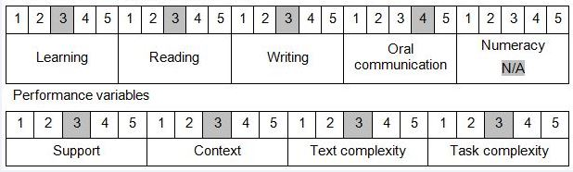

Further information on ACSF and the foundation skills underpinning this unit can be found in the Foundation Skills Guide http://www.govskills.com.au/guides/correctional-services/foundation-skills-guide on the GSA website.

Unit Mapping Information
Supersedes and is equivalent to CSCOFM310 Provide responsible care to people with a mental health problem and or condition.

Links
Companion Volume implementation guides are found in VETNet - https://vetnet.gov.au/Pages/TrainingDocs.aspx?q=114e25cd-3a2c-4490-baae-47d68dcd2fde
Companion Volume implementation guides are found in VETNet - https://vetnet.gov.au/Pages/TrainingDocs.aspx?q=114e25cd-3a2c-4490-baae-47d68dcd2fde
Companion Volume implementation guides are found in VETNet - https://vetnet.gov.au/Pages/TrainingDocs.aspx?q=114e25cd-3a2c-4490-baae-47d68dcd2fde
Companion Volume implementation guides are found in VETNet - https://vetnet.gov.au/Pages/TrainingDocs.aspx?q=114e25cd-3a2c-4490-baae-47d68dcd2fde

