CSCOFM006 Respond to offenders influenced by drugs or alcohol
Release: 1

CSCOFM006 Respond to offenders influenced by drugs or alcohol

Modification History
Release | Comments
1 | This unit was released in CSC Correctional Services Training Package release 1.0 and meets the Standards for Training Packages.  This unit supersedes and is equivalent to CSCOFM303A Respond to offenders influenced by drugs or alcohol.  - Element 2 wording revised for clarity

Application
This unit describes the skills required to provide an immediate response to offenders affected by drugs or alcohol and reduce the possibility of harm to the offender or others.

This unit applies to those working in a coordinated team to supervise offenders within a secure facility. Working as part of a coordinated team is integral to the role. Customisation will be required to accommodate the different work sites and defined work role contexts in which this unit will be applied. With contextualisation this unit may apply those working with non-offenders in other work environments.

The skills and knowledge described in this unit must be applied within the legislative, regulatory and policy environment in which they are carried out. Organisational policies and procedures must be consulted and adhered to, particularly those related to interaction with offenders, use of force and medical testing for drugs or alcohol.

Those undertaking this unit work with moderate support in roles involving routine tasks with a number of familiar steps.

No licensing, legislative or certification requirements apply to unit at the time of publication.

Competency Field
Offender management

Elements and Performance Criteria
ELEMENTS | PERFORMANCE CRITERIA
Elements describe the essential outcomes | Performance criteria describe the performance needed to demonstrate achievement of the element. Where bold italicised text is used, further information is detailed in the range of conditions section.
1. Provide an immediate response to offender's condition | 1.1 Assess the condition of offender through observation of external signs and responses.  1.2 Place offender in a location designed to protect the safety and welfare of people involved.  1.3 Monitor offender’s condition and behaviour and note all signs consistent with alcohol or drug use.  1.4 Note signs that are not consistent with drug or alcohol use and report these immediately.  1.5 Request emergency assistance where offender’s condition suggests the need for immediate medical attention based on emergency response criteria.  1.6 Request medical support for substance testing and risk assessment.  1.7 Monitor and record offender’s condition.
2. Reduce the possibility of harm | 2.1 Determine the need to use isolation and restraint according to risk assessment and organisational guidelines.  2.2 Maintain a calm and confident manner in all contact with offenders affected by drugs and alcohol.  2.3 Follow the organisation’s infection control guidelines in all actions to protect the safety of all people.  2.4 Respond to emergencies according to emergency procedures and degree of urgency.  2.5 Recruit specialist support immediately when indicated by offender’s condition and degree of risk.  2.6 Complete incident reports.

Foundation Skills
The foundation skills demands of this unit have been mapped for alignment with the Australian Core Skills Framework (ACSF). The following tables outline the performance levels indicated for successful attainment of the unit.

ACSF levels indicative of performance:
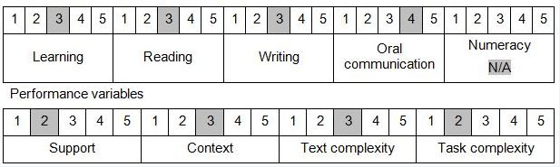

Further information on ACSF and the foundation skills underpinning this unit can be found in the Foundation Skills Guide http://www.govskills.com.au/guides/correctional-services/foundation-skills-guide on the GSA website.

Unit Mapping Information
Supersedes and is equivalent to CSCOFM303A Respond to offenders influenced by drugs or alcohol.

Links
GSA website - http://www.govskills.com.au
CSC Foundations Skills Guide - http://www.govskills.com.au/guides/correctional-services/foundation-skills-guide
CSC Knowledge Guide - http://www.govskills.com.au/guides/correctional-services/knowledge-guide
CSC Implementation Guide - http://www.govskills.com.au/guides/correctional-services/implementation-guide

