CSCOFM001 Support offender services
Release: 1

CSCOFM001 Support offender services

Modification History
Release | Comments
1 | This unit was released in CSC Correctional Services Training Package release 1.0 and meets the Standards for Training Packages.  This unit supersedes and is equivalent to CSCOFM201A Support offender services.

Application
This unit describes the skills required to match services to offenders and support those services.
This unit applies to those working with offenders in custody or in community services within a limited range of familiar and predictable contexts; working in a coordinated team is integral to the role. Support services can be defined as:
- information and advice
- administration and information processing
- maintenance of offender information
- processing of service agreements and allocations
- offender property and finances
- liaison with community agencies
- liaison with family support

The skills and knowledge described in this unit must be applied within the legislative, regulatory and policy environment in which they are carried out. Organisational policies and procedures must be consulted and adhered to, particularly those related to interaction with offenders and service provision.
Those undertaking this unit work with moderate support. The role involves explicit tasks involving a limited number of familiar steps.
No licensing, legislative or certification requirements apply to unit at the time of publication.

Competency Field
Offender management

Elements and Performance Criteria
ELEMENTS | PERFORMANCE CRITERIA
Elements describe the essential outcomes | Performance criteria describe the performance needed to demonstrate achievement of the element. Where bold italicised text is used, further information is detailed in the range of conditions section.
1. Match services to offenders’ needs | 1.1 Check and confirm offender files for accurate and relevant information on offender needs and circumstances.  1.2 Check and confirm information on available offender services, and use this to match suitable and effective services with offenders.  1.3 Identify the particular needs of offenders to ensure that services are clearly targeted.  1.4 Process requests from offenders and confirm service suitability from a defined range of options.  1.5 Report difficulties in matching offenders with support services to supervisor.
2. Support services | 2.1 Ensure that services are suitable to the needs and circumstances of offenders and are provided within determined timeframes.  2.2 Respond to inquiries promptly and according to accepted practice and standards.  2.3 Ensure services are adjusted to meet special needs of offenders.  2.4 Deal with difficult complaints and situations promptly, respectfully and according to procedures.  2.5 Maintain confidentiality of information according to information management procedures.  2.6 Process information from services to contribute to the evaluation of services to offenders.

Foundation Skills
The foundation skills demands of this unit have been mapped for alignment with the Australian Core Skills Framework (ACSF). The following tables outline the performance levels indicated for successful attainment of the unit.
ACSF levels indicative of performance:
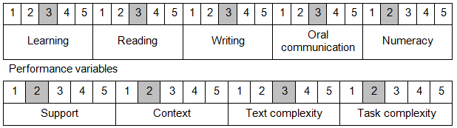

Further information on ACSF and the foundation skills underpinning this unit can be found in the Foundation Skills Guide http://www.govskills.com.au/guides/correctional-services/foundation-skills-guide on the GSA website.

Unit Mapping Information
Supersedes and is equivalent to CSCOFM201A Support offender services.

Links
Companion Volume implementation guides are found in VETNet - https://vetnet.gov.au/Pages/TrainingDocs.aspx?q=114e25cd-3a2c-4490-baae-47d68dcd2fde
Companion Volume implementation guides are found in VETNet - https://vetnet.gov.au/Pages/TrainingDocs.aspx?q=114e25cd-3a2c-4490-baae-47d68dcd2fde
Companion Volume implementation guides are found in VETNet - https://vetnet.gov.au/Pages/TrainingDocs.aspx?q=114e25cd-3a2c-4490-baae-47d68dcd2fde
Companion Volume implementation guides are found in VETNet - https://vetnet.gov.au/Pages/TrainingDocs.aspx?q=114e25cd-3a2c-4490-baae-47d68dcd2fde

