CSCDOG007 Train dogs in agility work
Release: 1

CSCDOG007 Train dogs in agility work

Modification History
Release | Comments
1 | This unit was released in CSC Correctional Services Training Package release 1.0 and meets the Standards for Training Packages.  This unit supersedes and is equivalent to CSCDH407A Train dogs in agility work.

Application
This unit describes the skills and knowledge required to develop a training plan for a dog/handler team; train dogs for agility work; maintain equipment used in training; and record and report on dog progress.
This unit outlines the performance standards for those working in a dog/handler team training dogs for agility, or training a dog/handler team. This unit may be contextualised to meet the needs of the organisation, particularly with regard to organisational policies and needs.
The skills and knowledge described in this unit must be applied within the legislative, regulatory and policy environment in which they are carried out. Organisational policies and procedures must be consulted and adhered to, particularly those related to the training and handling of dogs.
A person undertaking this unit would usually work autonomously using support from mostly familiar resources. The role requires complex task organisation and application of moderate analytical skills.
No licensing, legislative or certification requirements apply to this unit at the time of publication.

Competency Field
Dog handling

Elements and Performance Criteria
ELEMENTS | PERFORMANCE CRITERIA
Elements describe the essential outcomes | Performance criteria describe the performance needed to demonstrate achievement of the element. Where bold italicised text is used, further information is detailed in the range of conditions section.
1. Develop a plan for training | 1.1 Assess the training needs of the dog/handler team.  1.2 Develop a training plan that addresses the unique needs, strengths and weaknesses of the team.  1.3 Schedule training program to meet priority needs within the organisation.
2. Apply methods for developing skill in agility work | 2.1 Use organisation’s approved dog training methods.  2.2 Adapt equipment and exercise requirements to suit the capabilities and physical development of the individual dog.  2.3 Maintain a regular training pattern, giving opportunities for practising new or difficult skills.  2.4 Assess the dog’s response to training without delay.
3. Maintain equipment used for agility work | 3.1 Use and maintain training equipment appropriately.  3.2 Repair and/or replace faulty or hazardous equipment.  3.3 Record and report all equipment that needs repair or replacement.
4. Record and report on the progress of dog | 4.1 Complete training records for dogs as required by the organisation.  4.2 Report dog’s progress to appropriate people.  4.3 Review training plan to reflect the changing needs of the team and organisation.

Foundation Skills
The foundation skills demands of this unit have been mapped for alignment with the Australian Core Skills Framework (ACSF). The following tables outline the performance levels indicated for successful attainment of the unit.
ACSF levels indicative of performance:
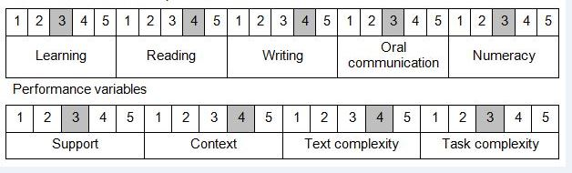

Further information on ACSF and the foundation skills underpinning this unit can be found in the Foundation Skills Guide http://www.govskills.com.au/guides/correctional-services/foundation-skills-guide on the GSA website.

Unit Mapping Information
Supersedes and is equivalent to CSCDH407A Train dogs in agility work.

Links
Companion Volume implementation guides are found in VETNet - https://vetnet.gov.au/Pages/TrainingDocs.aspx?q=114e25cd-3a2c-4490-baae-47d68dcd2fde
Companion Volume implementation guides are found in VETNet - https://vetnet.gov.au/Pages/TrainingDocs.aspx?q=114e25cd-3a2c-4490-baae-47d68dcd2fde
Companion Volume implementation guides are found in VETNet - https://vetnet.gov.au/Pages/TrainingDocs.aspx?q=114e25cd-3a2c-4490-baae-47d68dcd2fde
Companion Volume implementation guides are found in VETNet - https://vetnet.gov.au/Pages/TrainingDocs.aspx?q=114e25cd-3a2c-4490-baae-47d68dcd2fde

