CSCDOG004 Select dogs
Release: 1

CSCDOG004 Select dogs

Modification History
Release | Comments
1 | This unit was released in CSC Correctional Services Training Package release 1.0 and meets the Standards for Training Packages.  This unit supersedes and is equivalent to CSCDH405A Select dogs.

Application
This unit describes the skills required to identify the organisational purpose for selecting dogs, record information about dogs for selection and assess dogs for recruitment suitability.
The outcomes of this unit may be applied by a person working in a dog selection role in any organisation. This unit may be customised, particularly regarding the assessment of the temperament and characteristics of dogs based on different requirements of the organisation, functions of the work team and location.
The skills and knowledge described in this unit must be applied within the legislative, regulatory and policy environment in which they are carried out. Organisational policies and procedures must be consulted and adhered to, particularly those related to selecting dogs.
A person undertaking this unit would usually work autonomously using support from mostly familiar resources. The role requires complex task organisation and application of moderate analytical skills.
No licensing, legislative or certification requirements apply to this unit at the time of publication.

Competency Field
Dog handling

Elements and Performance Criteria
ELEMENTS | PERFORMANCE CRITERIA
Elements describe the essential outcomes | Performance criteria describe the performance needed to demonstrate achievement of the element. Where bold italicised text is used, further information is detailed in the range of conditions section.
1. Identify the purpose for selecting dogs | 1.1 Identify the roles of dogs working within the organisation and the purposes for their use.  1.2 Identify the purpose for which dogs will be selected and trained.
2. Record information about dogs for selection | 2.1 Set up and maintain a file recording the contact details of the source of the dog candidates.  2.2 Record information about available dogs relevant to their recruitment and training.
3. Assess dogs for recruitment | 3.1 Plan activities for dogs to enable assessment of suitability.  3.2 Observe and assess the dog for the desired characteristics, according to the criteria set by the organisation.  3.3 Record results of dog assessments.  3.4 Use assessment results to determine suitability of dogs for the organisation’s purposes.  3.5 Report selection results to the appropriate people.  3.6 Follow organisation’s procedures for acquiring or rejecting the dog.

Foundation Skills
The foundation skills demands of this unit have been mapped for alignment with the Australian Core Skills Framework (ACSF). The following tables outline the performance levels indicated for successful attainment of the unit.
ACSF levels indicative of performance:
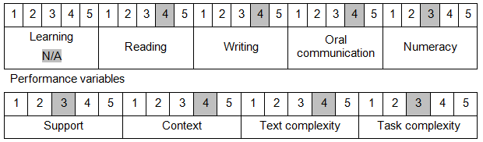

Further information on ACSF and the foundation skills underpinning this unit can be found in the Foundation Skills Guide http://www.govskills.com.au/guides/correctional-services/foundation-skills-guide on the GSA website.

Unit Mapping Information
Supersedes and is equivalent to CSCDH404A Select dogs.

Links
Companion Volume implementation guides are found in VETNet - https://vetnet.gov.au/Pages/TrainingDocs.aspx?q=114e25cd-3a2c-4490-baae-47d68dcd2fde
Companion Volume implementation guides are found in VETNet - https://vetnet.gov.au/Pages/TrainingDocs.aspx?q=114e25cd-3a2c-4490-baae-47d68dcd2fde
Companion Volume implementation guides are found in VETNet - https://vetnet.gov.au/Pages/TrainingDocs.aspx?q=114e25cd-3a2c-4490-baae-47d68dcd2fde
Companion Volume implementation guides are found in VETNet - https://vetnet.gov.au/Pages/TrainingDocs.aspx?q=114e25cd-3a2c-4490-baae-47d68dcd2fde

