BCC2006A Erect/dismantle fencing and gates
Release: 1

Modification History
Not Available

INTRODUCTION
This learning package is intended for use by those completing the Competency Unit BCC2006A – Erect/Dismantle Fencing and Gates as part of Basic Stream Skills within the CIVIL CONSTRUCTION SKILL STREAM of the National Construction Industry Competency Framework.

The theoretical and practical components in this package will help you complete the competency unit. All set tasks, including the activities and demonstrations, will show how the theory or content can be applied in on-site or simulated on-site conditions.

The competency unit Erect/Dismantle Fencing and Gates deals with the knowledge and skills required to plan erect/dismantle fencing and gates so includes specific details on: | - Planning and preparation  - Setting out and erection of industrial fencing  - Fit and secure industrial gates
One Assessment Task meets the requirements of the elements in this competency unit: | Assessment Task 1:  - Erect/Dismantle Fencing and Gates  - This learning package has been developed with one section, being closely aligned with the Assessment Task:
SECTION 1: | This contains learning resource material, self-checks and practical exercises required for the successful completion of the Assessment Criteria as shown in the Assessment Specifications for Task 1.  As well as self-check exercises and practical activities, your instructor will schedule additional oral and/or written tests, which may be similar to the self-check exercises. These tests will satisfy specific Assessment Criteria in the Assessment Tasks and will apply to your work environment.  When you have achieved all the Assessment Criteria in Assessment Task 1 and your work has been checked and certified by your instructor, you will have successfully completed the elements, which make up the competency unit BCC2006A – Erect/Dismantle Fencing and Gates.
WHAT IS PROVIDED | You will be provided with the essentials to successfully complete this competency, including:  - A learning package;  - A broad range of hand, power and pneumatic tools;
WHAT YOU PROVIDE | Appropriate personal protective clothing etc – to be advised by your instructor.
HOW TO USE THIS PACKAGE | This package has been designed so that you can work and learn at your own pace, incorporating into your own learning program:  - demonstrations of practical skills by your instructor or experienced tradesperson;  - planned and supervised practical application of your knowledge and skills;  - instruction in, and application of, safe working practices; and  - personal progress indicators through self-check exercises and practical activities.  It is suggested that you work through the sections as they are presented. By all means, fast-track any aspects/areas where you feel confident.  Self-Check Exercises have been included so that you can measure your own progress. These exercises, however, are not part of the formal assessment of competency.

GETTING TO "KNOW THE PACKAGE

Here is a strategy, which may help you become familiar with the contents of this package

Survey | Scan the whole package.  - Read the contents page and the introduction, then flip through the pages – glance at the headings.  - Notice that there are set tasks to be completed. The content relates to these tasks.
Ask | Ask about any topics, terms or details that are not clear to you at this stage.
Read | Read through the material, but do it actively. Jot down points, underline or highlight.  - Link the information with what you know already.  - Let the headings and sub-headings help you organise information.  - Remember that you will need the content to complete the tasks.
Review | At various stages, you will be directed to review the main points or complete a Self-Check Exercise to indicate how you are progressing. Make your own notes as well.
Instructor | Throughout this package, you will be required to attend practical demonstrations and receive instruction in the use of materials, tools and equipment.  Ask your instructor if you have any problems with:  - interpretation of content;  - procedures or processes; or  - availability of resources.

KEY TO SYMBOLS

Symbols are placed in the left hand margin to draw attention to the type of information commencing at that point.
The symbols used in this package are:

READ | Read | This is the essential information for the module.
DEMONSTRATION | Instructor Demonstration | At times, your instructor will give practical advice and demonstrate the use of tools/equipment.
SELF-CHECK | Self-Check Exercise | These are your progress indicators. Typical answers are also included.
PRACTICAL ACTIVITY | Practical Activity | The three activities allow for the application of the theory components.
SITE VISIT | Site Visit | Your instructor will schedule visits to appropriate sites..

SUMMARY OF TRAINING SPECIFICIATIONS

Unit Number and Title | BCC2006A – Erect/Dismantle Fencing and Gates
Pre-requisites | Concurrent assessment and pre-requisite relationship.
Elements of Competency | - Plan and Prepare Work  - Erect Fence  - Erect Gates and Signage  - Maintain Fencing and Gates  - Remove and Make Good Clean Up
Delivery | Delivery methods must provide for the demonstration of competence in skills specified in all learning outcomes, either in on-site or simulated on-site conditions.
Resource Implications | - Materials selected and identified appropriate to the tasks  - Tools, plant and equipment  - Suitable workplace location/simulated workplace environment  - Appropriate communication of documentation relative to the tasks  Desired training qualifications and training required for those involved in the instructional process are:  - Possess competency and knowledge relevant to the competency standard at a level equivalent to or higher  - than the competency under assessment;  - Possess a level of specific and relevant quality industry experience in order relate competency to current industry practice;  - Provide evidence of having successfully completed or being assessed competent in a relevant course of instructional skills; or  - Provide formal evidence of successfully completing the requirements of an established process for Recognition of Prior Learning (RPL) or Recognition or Current Competencies (RCC) equivalent to the required competencies and knowledge of instructional skills.

TRAINING SPECIFICATION

Unit Number and Title | BCC2006A – Erect/Dismantle Fencing and Gates
Element of Competency | Performance Criteria
Plan and Prepare Work | OH&S requirements adhered to;  - Quality Assurance requirements recognised and adhered to;  - Location of fencing and gates determined from site plans;  - Materials and quantities determined from site drawings and specifications;  - Personal protective equipment selected, correctly fitted and used;  - Tools and equipment selected consistent with requirements of job.
Erect Fence | Fence line and post hole position set out to requirements of site plans and specifications;  - Post holes excavated to specifications;  - Fence posts erected in place, plumb and to alignment in accordance with specifications;  - Fence rails and cladding or mesh fixed to posts to specifications.
Erect Gates and Signage | Gates fitted and secured to requirements of site drawings and specifications;  - Signage installed at entry gates in accordance with site OH&S and security requirements.
Maintain Fencing and Gates | - Fencing and gates maintained to completed construction condition.
Remove and Make Good | - Gates and fencing where required, dismantled and removed from site;  - Area made good to specification.
Clean Up | - Tools and equipment cleaned, maintained and stored;  - Waste and unwanted material cleared and removed from site;  - Tools and equipment cleaned, maintained and stored.

ASSESSMENT SPECIFICATIONS

Unit Number and Title | BCC2006A – Erect/Dismantle Fencing and Gates
Guidelines for the Assessor | This is a supervised assessment requiring observation of the process with individual final assessment tasks.  Forms of assessment to be considered by the assessor are as follows:  - Written/oral tests;  - Observation;  - Demonstrations;  - Practical tasks and/or projects.  Assessment may also be demonstrated through other forms of assessment not included in the above methodology including:  - Simulation of real-life work activity;  - Individual projects;  - Portfolio;  - Recognition of Prior Learning/Recognition of Current  - Competencies
Method and Context of Assessment | Competence should be assessed under guidance checking at various stages of the process and at the completion of task/activity against the elements and performance criteria specified in the standard. Competency may be assessed in the workplace or simulated workplace setting.
Human Resource Implications | - Desired assessor qualifications and training required to assess would be as follows:  - Possess competency and knowledge relevant to the competency standard at a level equivalent to or higher than the competency under assessment;  - Having completed a course in instruction for registration as an assessor with CTA or be accredited as a Registered Training Organisation (RTO) for assessor services;  - Possess a level of specific and relevant quantity industry experience in order to relate competency to current industry practice.  - Training qualifications required:  - Possess competency and knowledge relevant to the competency standard at a level equivalent to or higher than the competency to be achieved.  - Having completed a course or being assessed competent in a course of instructional/assessment skills.  - Possess a level of specific and relevant quality industry experience in order to relate competency to current industry practice.
Physical Resource Implications | The following resources should be made available:  - General construction materials relative to the work orientation  - Hand and power tools plant and equipment appropriate to the civil construction process  - Suitable work area appropriate to the construction activity
Range of Variables | This unit applies to all types of fencing construction including timber, concrete and metal posts as well as timber and metal railing. Fencing can be closed with timber cladding or sheet material, or can be open with wire or cyclone mesh.

EVIDENCE GUIDE
Competency is to be demonstrated by the safe and effective preparation and erection of two (2) separate types of fencing listed in the range statement relative to the work orientation.

Critical Aspects of Evidence | It is essential that competence is observed in the following aspects:  - Compliance with Occupational Health and Safety regulations and State/Territory legislation applicable to work place operations.  - Compliance with organisational policies and procedures including Quality Assurance requirements.  - Correct procedures during construction.  - Safe and effective operational use of tools, plant and equipment, and communications to enable appropriate erecting/dismantling of fencing and gates.
Pre-requisite Relationship of Units | Appropriate Basic Industry Skills units of competence relative to the work orientation.
Underpinning Knowledge and Skills | Knowledge  A knowledge of:  - Workplace and equipment safety requirements.  - Measurements  - Hand tools and equipment  - Materials and handling methods  - Quality Assurance  - Workplace Communication  Skills  The ability to:  - Work safely to instructions  - Use power tools and hand tools  - Handle material  - Select material  - Apply Quality Assurance  - Communicate effectively

INTEGRATED PROJECT-BASED TRAINING
It should be noted that all training in this program is project-based.
The training must integrate all competencies including the use of tools and equipment.
The knowledge and skills you gained in this program regarding good communication, quality concepts and OH&S must be practiced again in all competencies.

KEY COMPETENCY LEVELS

Collecting, analysing and organising ideas & information | Communicating ideas and information | Planning and organising activities | Working with others and in teams | Solving problems | Using mathematical ideas and techniques | Using technology
Level 1 | Level 1 | Level 1 | Level 1 | Level 1 | Level 1 | Level 1

CHECK LIST FOR ASSESSMENT RESOURCES

Title | Identifies the title of the learning resource that related to the standard being assessed.
Unit(s) of Competence | Identifies conditions under which assessment can be conducted based on information from ‘range of variables statements’ and ‘evidence guides’ in competency standards.
Instructions for Assessors | Informs the assessor about the scope of the assessment resource ie. the assessment methods to be used and the conditions of assessment as well as the procedure to follow in preparing, conducting and reviewing the assessment.
Direct Observation Checklist | Checklist for outcomes of observations of performance and other forms of evidence eg. Responses to questions, related directly to ‘performance criteria’ and ‘evidence guides’ in competency standards. (Refer assessment specification in Learning Materials for each competency standard.)
Other Evidence Gathering Methods | Instructions for assessors on methods of gathering indirect and supplementary forms of evidence. This may include assessor guidelines and/or outlines of assessment tasks for:  - Products or services produced by assessee;  - Third party reports;  - Individual/group projects;  - Written tests;  - Portfolios;  - Structured oral questioning; and  - Test banks.
Record of Assessment Outcomes | Identifies way in which outcomes of different evidence gathering techniques, incorporated in assessment resource, are recorded.
Reference Documentation | Identifies reference material required to support specific evidence gathering techniques. This may include:  - Organisational policies and procedures;  - Manufacturer’s instructions;  - Safety regulations;  - Product information; and  - Legislation.
Assessor Note | Assessors may find it useful in creating a checklist to refer t the non-endorsable learning resource materials access list for the appropriate learning resource packages.

ASSESSMENT TASKS

ASSESSMENT TASK 1  Incorporates: Erect/Dismantle Fencing and Gates. | Practical to demonstrate the identification, selection, erection and dismantling of appropriate fences, gates and entry-gate signage for specified sites.  Written and/or oral responses to questions related to identification, selection, use and maintenance of plant and machinery involved in the process of erecting and dismantling fences and gates and restoring sites.  Practical tasks which identify sound housekeeping, maintenance and clean up  The procedures above could be carried out in one or more projects.

ITEM | ASSESSMENT CRITERIA | ACHIEVED
1 | Determine from site plans and drawings locations of fences and gates.
2 | Determines from site drawings and specifications materials and quantities.
3 | Selects, fits and uses appropriate personal safety equipment.
4 | Selects and uses tools and equipment consistent with the task.
5 | Sets out fence line and post holes in accordance with site plans and drawings.
6 | Excavates post holes to specifications.
7 | Places, plumbs and lines fence posts in accordance with the specifications.
8 | Fixes fence rails, cladding and mesh to specifications.
9 | Fits and secures gate/s in accordance with site drawings and specifications.
10 | Installs signage at entry gates in accordance with OH&S and security requirements.
11 | Clears waste and excess materials from site.
12 | Cleans, maintains and stores tools and equipment.
13 | Maintains fences and gates to job completion.
14 | Dismantles fences and gates and removes from site where required.
15 | Make good all areas to design requirements.
16 | Demonstrates in all work practices current OH&S requirements are adopted and that pre-determined standards of quality are observed fully.
All work practices must ensure that current OH&S requirements are adopted.
Items 1 to 16 must be performed fully.

SECTION OVERVIEW

Section 1: Erect/Dismantle Fencing and Gates | BCC2006A: Erect/Dismantle Fencing and Gates
In this section you will find learning resources support the underpinning knowledge and skills relating to: | Competency BCC2006A, elements 1, 2, 3, 4, 5 and 6:  1. Plan and Prepare Work  2. Erect Fences  3. Erect Gates and Signage  4. Maintain Fencing and Gates  5. Remove and Make God  6. Clean Up

INTRODUCTION

In general terms, the programe section deals with: | - Determining from site plans and drawings location of fences and gates.  - Determining from site drawings and specifications materials and quantities.  - Selecting, fitting and use appropriate personal safety equipment.  - Selecting and using tools and equipment consistent with the task.  - Setting out fence line and post holes in accordance with site plans and drawings. Excavating post holes to specifications.  - Placing, plumbing and lining fence posts in accordance with specifications. Fixing fence rails, cladding and mesh to specifications.  - Fitting and securing gates in accordance with site drawings and specifications.  - Installing signage at entry gates in accordance with OH&S and security/requirements. Clearing waste and excess materials from site.  - Cleaning, maintaining and store tools and equipment.  - Maintaining fences and gates to job completion.  - Dismantling fences and gates and removing from site where required.  - Making good all areas to design requirements.  These components include the essential information you will need to complete the Assessment Task to:  - Plan and prepare work to recognise, erect, maintain and dismantle fences, gates and entry- gate signage in compliance with the OH&S requirements for construction sites.  The information relating to Erect/Dismantle Fencing and Gates will be presented under eight topics:  - Why Fence?  - Personal Safety Equipment  - Predetermined Standards of Quality  - Planning and Preparation  - Setting Out and Erecting an Industrial Fence  - Fit and Secure Industrial Gates Installation of Signs at Entry Gates Maintenance of Fences and Gates (Industrial)
1. WHY FENCE? | There are numerous reasons for fencing. Some are to:  - mark boundaries;  - prevent people from trespassing;  - facilitate domestic stock management;  - protect crops;  - keep out feral animals;  - prevent soil erosion;  - protect water catchment areas;  - protect people from harm;  - and secure specific areas.  Types of Fencing  - rural;  - suburban;  - industrial;  - security; and  - sporting enclosures.  In the civil construction industry, the most common type of fencing you will encounter is the industrial type usually constructed of chainwire mesh, galvanised end and intermediate steel posts and topped with barbed wire strands.  It is often the case that fencing for construction sites if of temporary nature and at the completion of the project it is necessary to dismantle the fence.

Terms Commonly Used in Industrial Fencing

Bracing Stay | The diagonal tubular steel compression member used at end, corner and gate posts.
Back Stay | The diagonal tubular steel member at 90 degrees to the fence line, used for unstable site conditions.
Fence Post | An upright member for supporting fencing material.
Corner Post | A larger fence post positioned at corners and changes of direction of alignment of a fence.
End Posts | The fence posts at the ends of a line of fencing.
Gate Posts | The two fence posts forming a gateway.
Intermediate Posts | Fence posts positioned at regular intervals between corner and/or end posts to provide support for the fencing materials.
Chainwire | A wound and interwoven wire mesh.
Selvedges | Top and bottom edges of the chainwire.
Cable Wire | Longitudinal wires supporting the chainwire between fence posts.
Wire | The wire that is used to tie chainwire to cable wires and fence posts
Barbed Wire | The twisted longitudinal wires to which are attached the four-point barbs
Rail | A pipe secured between posts with galvanised split fittings.
Gate | A tubular steel rectangular shaped frame covered with chainwire, hinged on a gate post and used to close a gateway.

2. PERSONAL SAFETY EQUIPMENT | - Long sleeved shirt and long trousers  - Gloves  - Safety glasses  - Hard toe capped boots  - Hard hat (if necessary)
Tools and Equipment | - Brushcutter  - Cement mixer  - Posthole digger (hand or power auger) Post power driver  - Grader  - Power hammer drill and bits  - String line and pegs Line sighters Mattock  - Long handled narrow shovel  - Sledge hammer Tape measure Fencing pliers Crimping tool  - Flat steel strainer bar  - Crow bar  - Tamper bar  - Wire strainer with tension indicator and strainer bar  - Adjustable spanner Wire or bolt cutter Hammer  - Wire twisting tool
3. PREDETERMINED STANDARDS OF QUALITY | AUSTRALIAN STANDARD 2423 (1991) Galvanised Wire Fencing Products  AUSTRALIAN STANDARD 1650 (1981) Galvanised Coatings  AUSTRALIAN STANDARD 1391 (1991) Method of Tensile Testing of Metal  AUSTRALIAN STANDARD 1725 (1975) Galvanised Fences Chainwire Security Fences and Gates  AUSTRALIAN STANDARD 1742.5 Facility Name Signs
Occupational Health Safety Provisions | There are no specific regulations relating to safety when erecting or dismantling fencing or gates. There is a general responsibility upon an employer to provide a safe and healthy working environment for employees and accordingly the employer must develop a policy and procedures on health and safety issues, which must be communicated to employees or sub-contractors. All work practices and procedures must comply with the policies and instructions of the employer.  Check with your supervisor to find out what are the policies and procedures in relation to fencing and signage.  Also see Australian Standard AS1470 - 1986 "Health and Safety at Work Principles and Practices".
4. PLANNING AND PREPARATION | Site plans and drawings will generally be provided by the supervisor and it can be assumed that prior approvals from council and relevant authorities have been obtained for the job in hand. The type of industrial fencing will also be specified including gates and signage.  From the site plans, drawings and specifications you will be able to determine:- the use of appropriate personal safety equipment;  - the type and quality of materials required for the job;  - the necessary tools and equipment;  - to what level the fence is to be erected;  - the location of gates;  - the positioning of signs; and  - whether the fence is a permanent of temporary fixture.  The time spent on planning and preparing before the actual construction of the job will save time and effort in the long term.
5. SETTING OUT AND ERECTION OF INDUSTRIAL FENCING | The first step in building a fence, no matter what type, is to locate where and what level the fence is to be erected.  We will start with - to what level the fence is to be erected at.  This van vary for several reasons, for example:  - Is this the finished ground level?  - Is there a surface to go on top? eg Hotmix  - Is the ground level constant? ie Hollows and high spots.  Once the level has been established you should now be looking at location. For example is the fence on the boundary? This needs to be known as in some cases the fence may need to be erected inside the boundary so there is no overhang of the boundary line. Positioning of a fence is very important because if erected in the wrong place it can become very expensive to move it to the correct position.  Once levels have been decide and location has been identified it is time to set out your fence line. If pegs are in place and you want to place fence post in exact position there is a very easy method to determine this. This is as follows:  Measure off boundary peg a set distance and drive another peg into the ground at 90o to fence line then do the same in line with fence as shown in Figure 1. You are then able to dig your post hole and place your new post to the exact centre of the corner or boundary peg.

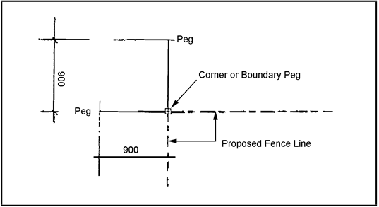

FIGURE 1 MAINTAIN AND CHECK PEGS

This system allows you to maintain and check pegs to be sure the fence is in the correct position.
Now that you have established the level and location accurately, you are now ready to set out the fence.
This will be broken down into steps:
Mark posts for position of cable wires or top and bottom rail.
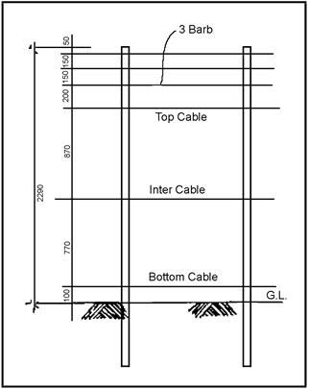

Figure 2 CABLE/WIRE SET OUT FOR A 1800 + 3 BARB FENCE
Source: Smorgan Fencing

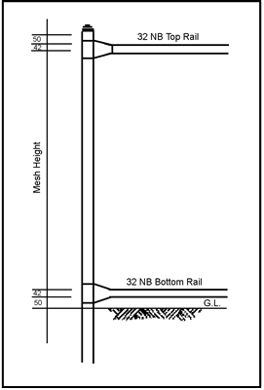

Figure 3 RAIL POSITIONS FOR TOP AND BOTTOM RAIL FENCE
Source: Smorgan Fencing

Run a string line the length of the fence; in some cases on long runs it is simpler to run a 3.15 mm cable wire along line and attach to a sturdy peg at one end and strained to a peg at the other end. This cable or string line should be tight and be at the ground level mark on the strainer posts. If hollows are encountered, place a heavy object on the line as illustrated below.

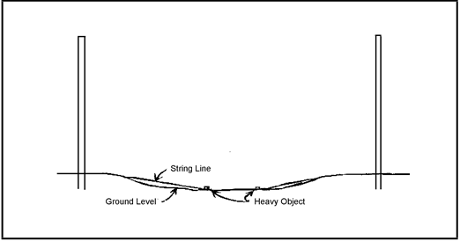

Figure 4 STRING LINE

Mark out post centres and if using diagonal struts mark these also. Post spacings should always be marked out equally so that the spacings are consistent.
For example, say we have a fence 350 m long we mark out the first 300 m at 4.0 m centres we then divide up the last 50 m into equal spacings and if we do this we end up with the last
12 posts in at 3.85 centres. At not stage should we go over 4.0 m or under 3.6 m. Diagonal struts are marked to the measurements as given in the specifications.
At this point a check should be taken to make sure all the above steps have been taken. Now the fence is positioned correctly, levels established and posts set out it is the time to
think about digging the holes. A fence is only as good as the strainer assemblies so short cuts taken on strainers will only involve more work later on. Strainer or corner posts should be 250 mm wide at top and 350 mm wide at bottom. If shaped with 350 mm at top and 250 mm at bottom strainer will easily pull out of the ground.
Line post holes should be 200mm in diameter and be dug so that 75mm is on the outside of the line or string line. Refer Figure 5.
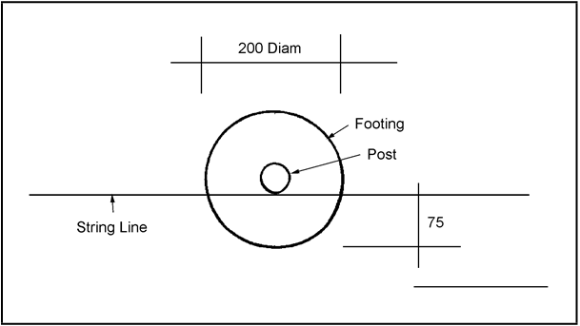

Figure 5 POSITION OF POST HOLES

When all post holes are dug, care should be taken to make sure the string line or line wire is not fouled by earth removed from holes. The next stage is to set up posts.
Place posts in holes.
Set up end and corner posts by placing in position with the ground level mark on ground level and plumbed with a level both ways
Make sure string line is on ground level, mark may need to be weighted down. Progressively move along the fence line standing posts to string line.
A small shovel of earth may be stamped around base of posts to hold toe of post in correct position.
Once all posts are set up, now is the time to concrete them in place.
Concrete should be placed in holes carefully. If just dumped in, can cause toe of post to move out of line.
The holes should be filled with concrete to the ground level mark, if filled above this can cause problems later when erecting the chainwire.
The posts should now be rechecked for level.
Leave posts and strainers for at least 24 hours before attempting to wirefence.
In circumstances that specify a temporary fence, it may not always be necessary to place concrete into postholes. Longer posts are sometimes used and driven into the holes using a post power driver. Once the concrete is cured or the posts correctly positioned we can now carry on with the fence.
The first step is to set up the struts. If diagonal struts are used it is a simple task of fitting the clip tees to hold the struts against the posts. If horizontal struts are used the rail should be clip teed between the posts. Once this is done a turnbuckle is attached to the strainer by a double tie of cable wire at the base of the post. A cable wire is then attached to the other end of turnbuckle and taken to the line post that the rail is attached to and wound around that post twice above the clip tee then back down to the turnbuckle. This cable should be tight as this is done to aid with the tightness and appearance. The cable should be twisted two or three times at the top. The turnbuckle should be then tightened to help keep this wire tight.
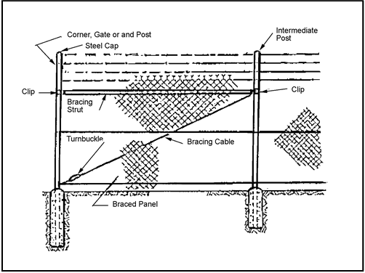
Figure 6 HORIZONTAL STRUT

Diagonal Struts should have holes 300 mm in diameter as these are part of the strainer assembly. The top end of the diagonal strut should be placed against the strainer post 50 mm down from the top cable mark.

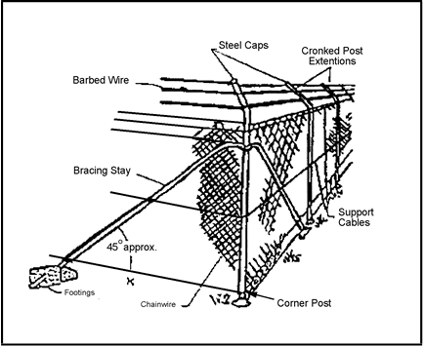
Figure 7 DIAGONAL STRUT

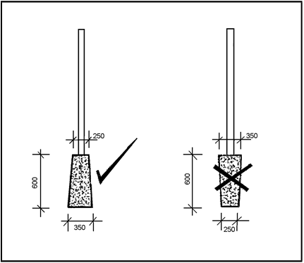

Figure 8 GATE POST FOUNDATIONS

When setting out gate posts, the measurement given is the distance between the posts not the gate size, i.e. for double gates: size of each gate + centre clearance + hinge clearance x 2 = opening between gate posts.
With the diagonal or horizontal bracing in place on all corners, ends and gate post, we are now able to wire fence.
There are two methods of wiring a fence:
(i) With helicoil wire, ie 4 mm HT Wire,
(ii) With two 3.15 mm soft cables twisted together.
Helicoil is excellent for long runs of fence as it maintains its tension well but is very hard to tension on short runs of fence. Therefore, it should only be used on long runs - say exceeding 150 mm.
Twisted 3.1 mm cables can be used on any length of fence from short to long, but usually are more prone to loosening tension on longer runs.

Twisted Cables
The first wire should be run out the length of the fence on the outside of the post that the chainwire is going to be fitted to and tied off to the strainer post. Then, working your way back along the fence line, loop the wire over every second post so that the wire leaves the post on the outside face. Once you have worked your way back to where you started, run out the second wire and again working your way back loop over the posts you missed with your first wire. Tie off when you get back to the strainer you started at.
Now is the time to start twisting the cables. Working along the fence, twist one side of the posts only until reaching the strainer post. You should only need approximately 4-5 twists on this side. Working back the other way will tension the cables. Care should be taken that on the return trip the twists should be done in the opposite direction so that the first twist does not come undone. As you work your way back along the fence line, the cable will tighen.

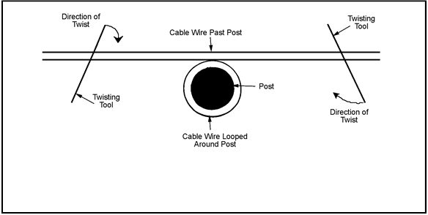
Figure 9 TWISTED CABLES
Source: Smorgan Fencing

Helicoil
With helicoil for each run cable you only require one run of Helicoil cable as it is 4.0mm soft wire with crimp. The crimp in the wire helps maintain the tension in the wire.

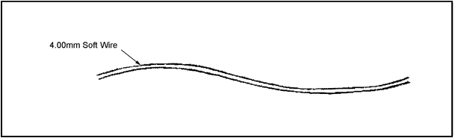

Figure 10 HELICOIL WIRE

Run helicoil wire along the side of the fence the chainwire is to go on and tie to strainer post with a conventional twist method.

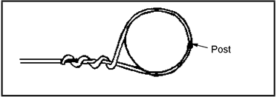

Figure 11 CONVENTIONAL TWIST METHOD

When the wire is tied off now is the time to strain the helicoil using a tool called a plain wire strainer illustrated below.

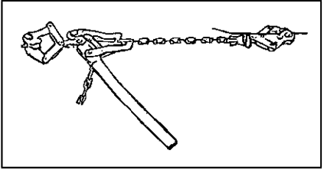
Figure 12 PLAIN WIRE STRAINER

When straining helicoil, take wire around strainer post and attach plain wire strain back onto the cable running along the fence line as below. Once the wire is strained place the twisting tool in the gap between the two cables where they go around the post and give approximately 5 turns. This will keep the tension on the cables with conventional tie off. Helicoil requires tying off to posts with a double tie that is the tie wire goes around the post twice before being twisted. A double tie holds cables more securely than a single tie.

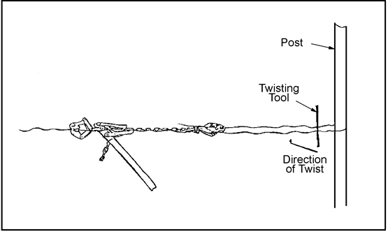

Figure 13 TYING OFF HELICOIL WIRE
Source: Smorgan Fencing

Barbed Wire
Care must be taken when running barbed wire as it will catch on anything and everything including the fence erector.
Barbed wire should be tied off to strainer post, run out to next strainer and strained. Care should be taken not to over strain wires at the top of posts as the leverage at this height can lift the strainer posts.
Each barb should be strained and tied off at strainer posts before the next barb is run out.
Once all barbs are run out and strained they should be tied off to line posts with a double tie with the tie wire in the indentation of the post.

Chainwire

Rolls of chainwire, wherever possible, should be rolled out on the ground as this makes joining rolls together a lot easier.
The first roll should be rolled out along the ground with the end tied off to the strainer posts. These ties should be not more than 200 mm apart, if any further apart the first diamond in the chainwire can pull out of shape.
At the end of each roll the last diamond will only be a half diamond, and at the beginning of each roll there is a full diamond.

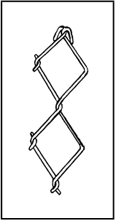
Figure 14 FULL DIAMOND

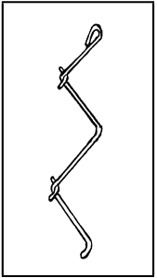

Figure 15 HALF DIAMOND
Also at the end of each roll there will be a spare strand for joining rolls together. When joining rolls together roll the first roll out completely and stretch the chainwire by picking up the end of the roll and pulling along the line of the fence. It is important to do this and to stretch the roll as it is very hard to get the slack out of any more than about 30 m of chainwire. Once the chainwire is stretched lay the next roll at the end of previous roll. You should have a half diamond and a full diamond on the new roll. Lay end diamonds about 25 mm apart and take spare strand of wire, by inserting into the full diamond first and then turning the strand through the chainwire until the two rolls are stitched together.

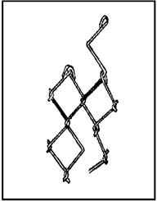
Figure 16 JOINING

Once the rolls are joined, unroll the next roll, stretch it and join it to the next roll. Continue until you have completed the run of the fence.
Start back at the point where the chainwire was started, and working your way back to the end you are going to strain from, loosely tie the chainwire to the top cable. Once the chainwire is standing insert a piece of 25 mm x 3 mm flat steel approximately 1600 mm long into the chainwire approximately 1.5 m to 2.0 m from the strainer. This is used as a strainer bar as illustrated below.
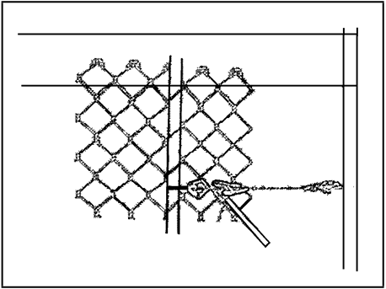
Figure 17 STRAINER BAR
Source: Smorgan Fencing

The chainwire should be strained to a point so that with one hand you cannot open the diamond of the chainwire more than 5 mm.

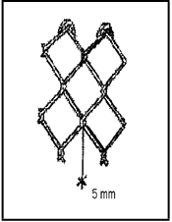

Figure 18 Chainwire Strain
When chainwire is strained to the correct tension, check along the fenceline to make sure the tension is even.

Once you are satisfied with the strain of the chainwire, lacing of the end posts is the next step. For this we use a lacing needle as illustrated.

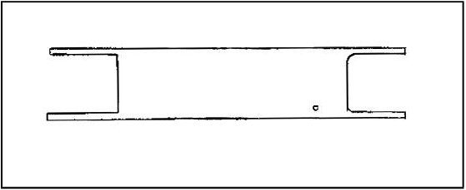
Figure 19 LACING NEEDLE
Source: Smorgan Fencing

The wire is wrapped around the needle end to end until it will only just fit through the diamond on the chainwire.
With lacing, start at the top with the lacing wire wrapped at least twice around the strand at the top diamond then through the diamond and around the post. This needs to be done twice at the top diamond and twice at the bottom diamond. Once laced, remove the plain wire strainer.
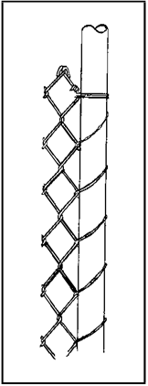
Figure 20 LACING

The chainwire needs now to be post tied, that is, at every post the chain wire is tied to the lone posts with double ties halfway between top and middle cable and halfway between middle cable and bottom cable. At this time the chainwire should be set at correct height as illustrated in Figure 21.
On completion of the tying of the posts the chainwire needs to be clipped to the cable wires at approximately 300 mm centres, except in the case where PVC covered chainwire is used then the chainwire is tied to the cables at approximately 450 mm centres.

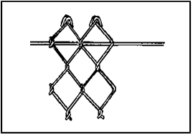

Figure 21 CHAINWIRE SET AT CORRECT HEIGHT

AN EXAMPLE OF SPECIFICATIONS FOR CHAINWIRE MESH FENCES AND GATES

Details of Fence Posts and Footings

TYPE OF POST | NOMINAL BORE AND TYPE | MAXIMUM SPACING CENTRES | MINIMUM FOOTINGS SIZE OF
 |  |  | Diam. (mm) | Depth (mm)
Intermediate | 40 XDI tube | 4500 mm | 150 | 500
End | 50 NB medium | As required | 300 | 750
Comer | 50 NB medium | As required | 300 | 750

Details of Gate Posts and Footings

GATE DESIGN CODE | NOMINAL OPENING MM | NOMINAL BORE AND MIN. SIZE OF FOOTING TYPE MM
 |  |  | Diam (mm) | Depth (mm)
G | 900, 1050, 1200 | 50 NB. Light | 230 | 900
H | 2700, 3000, 3600 | 50 NB. Light | 230 | 900
C | 900, 1050, 1200 | 50 NB. Light | 230 | 900
E | 2400, 2700, 3000, 3600 | 50 NB. Light | 230 | 900

Other details, such as specifications for various wire thickness, tensioning of wires etc can be found in the cyclone security fencing specifications manual.

Typical 3 Barb Fence

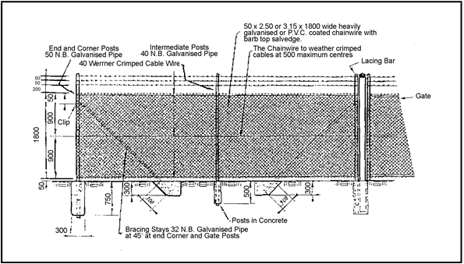
Figure 22 TYPICAL 3 BARB FENCE

Alternatives
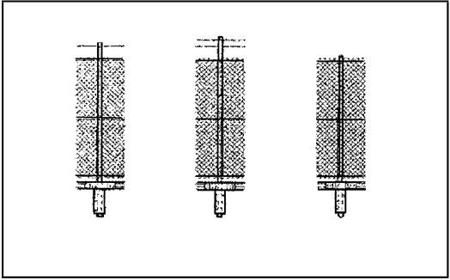

Figure 23 SINGLE BARB, 2 ROW BARB, PLAIN FENCE
Source: Smorgan Fencing
Clear waste and excess materials from site, paying particular attention to smaller pieces of wire. A practical suggestion may be to carry a bucket along the fence line and place off cuts of tie-wire directly into bucket.

6. FIT AND SECURE INDUSTRIAL GATES | Ascertain from drawings the number of gates required, the size, (whether single and/or double) and the type (whether barbed top or plain top). The height of the gates generally match the height of the fence.  When the specified gateway opening has been established, place the gate posts in position along the fenceline (in accordance with drawings and specifications). For gateway openings between 900 mm to 3600 mm, the minimum diameter of the posts is 230 mm and the minimum depth of the footing is 900 mm.  Clip type hinges are commonly used on Industrial gates and a collar is usually welded to the gate frame to provide a bearing surface for either the top or bottom hinge.  Assemble the clip hinge fittings to the gate post and gate frame, ensuring that the gate opens freely. The clearance under the gates, when in the closed position shall be sufficiently small to clear the surface and maintain security.  Drop bolts, which are fitted, to double gates must be accommodated to keepers set in ground level footings of not less than 150 mm diameter by 350 mm deep.  The locking of gates may be either by drop bolts suitable for locking or by chain. Hand holes are usually incorporated in the gates so that the lock will be accessible from either side of the gates. For single gates, a shoot bolt is generally set into a hand hole for the attachment of a padlock.

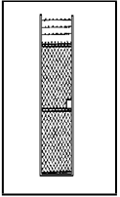
Figure 24 SINGLE GATE DESIGN "G"

Diagram unavailable

Figure 25 DOUBLE GATE DESIGN "H"

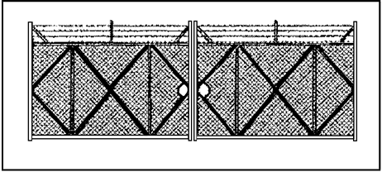

Figure 26 DOUBLE GATE DESIGN "K"

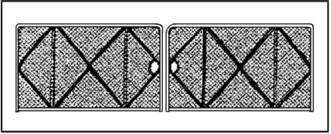
Figure 27 DOUBLE GATE DESIGN "L"

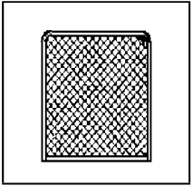

Figure 28 SINGLE GATE DESIGN "A"

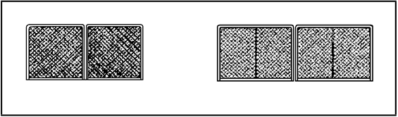

Figure 29 DOUBLE GATE DESIGN "F"
Source: Smorgan Fencing

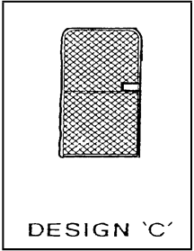
Figure 30 SINGLE GATE DESIGN "C" FENCING

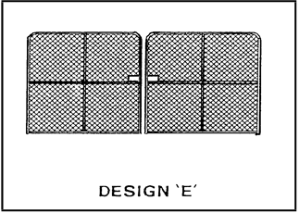

Figure 31 DOUBLE GATE DESIGN "E"
Source: Smorgan Fencing

7. INSTALLATION OF SIGNS AT ENTRY GATES | Ascertain from you supervisor the type of signs to be placed either on the gates or on the fence near the entry. The company will have a policy on safety requirements for the area within or adjacent to the compound.  Typical signs used for this purpose may refer to:  - Trucks entering  - A speed limit within the compound area  - A hard hat area  - Dust nuisance  - Heavy plant in use  Facility and warning signs, as with most types of signage must comply with Australian Standards which specify the shape, colour, size, height and thickness of signs.  Common sense also must prevail so that any signs do not obstruct vision and yet must be installed in the most appropriately visible position.
8. MAINTENANCE OF FENCES AND GATES (INDUSTRIAL) | At times, it is necessary to repair fences and gates because of accidents, vandalism or storms.  It may be necessary to realign posts, refit a new section of chainmesh wire or refit new clips or ties and retension barbed wire. If damage is severe it may be more viable to replace a whole section of the fence, however if minimal, simple repairs can be carried out.  Maintaining fences may require refitting clips or ties to secure the chainwire mesh to the cable wire wires. Should the mesh become bowed, the damaged section can be removed by using bolt cutters ensuring that one end of the chainwire is a full diamond. The end of the new section of chain wire to be fitted should be a half diamond so that the strand used for joining the two sections can be inserted into the full diamond end of the new chainwire. Continue twisting the strand through the chainwire end until the two sections are stitched together. Remove the lacing at the closest end post and strain the chainwire to the correct strain. Replace the chainmesh to the end post, refit clips to the cable wire.  When maintaining gates, ensure that they operate freely. If not, check that the clip hinges are in the correct position and that the gates have not sagged. (It may be necessary to attend to the collar on the gate frame or to replace the hinges. The keepers set in the ground should also be checked for damage or cleaned out if applicable.)  DISMANTLING INDUSTRIAL FENCING AND GATES  Many industrial fences and gates are temporary structures and require dismantling at the completion of a project.  Extreme care should be taken when performing this task particularly when cutting the barbed wire strands, which have been tensioned. Personnel must not stand anywhere near the vicinity of the fence line whilst the barbed wire is being cut. The person performing the cutting must stand in the opposite direction to the fenceline being removed to avoid the backlash.  The barbed strands are removed firstly, one by one, starting at the top. Roll up the lengths on the ground.  Remove all clips or ties holding chainmesh to cable wires ensuring that all clips are discarded into a bucket. Then remove lacing wire from end posts and allow chainmesh to fall onto the ground. Tightly, roll up chainmesh, making certain that the selvedges of the chainwire are not entangled. It is often practical to measure the fenceline before dismantling so that tags marked with correct length can be attached to the rolls of wire, which can be re-used for another job.  The gates are dismantled by removing the clip type hinges from the gate posts. Remember to lift out the keepers set onto the ground by digging and using a crow-bar or lifting equipment.  Finally the posts are removed by using chain lifting equipment which can usually lift the concrete footings. If difficulty is experienced, the use of a backhoe is helpful or manual digging around the footings may be necessary to loosen the posts. Fill in the holes and tamp the soil. Where applicable, the dismantled fencing may have to be removed from the site.  CLEARING THE SITE  After the erection or the dismantling of fencing, it is important to ensure that the site is cleared from waste and excess materials.  Any excess materials should be removed and retained for other jobs or maintenance. Excess soil from posthole diggings must be cleared or used to fill low spots.  Careful inspection should be made along the fenceline to ensure that no pieces of wire, or clips are left, which could cause injury or damage to equipment.  CLEAN AND MAINTAIN TOOLS AND EQUIPMENT  All hand tools, equipment and machinery must be cleaned and checked for damage before storing. This practice also applies to personal safety equipment.

SUMMARY
In this section you covered the reasons for fencing and the types of fencing used in the construction industry.

You should now be able to perform all the following: | The terms commonly used in industrial fencing and their definitions as well as personal safety equipment and tools and equipment used when fencing.  The Australian Standards which are applicable to fencing along with compliance to the employer’s policy and procedures on health and safety requirements.  The importance of planning and preparation for the job and the processes involved in setting out and erecting an industrial fence, as well as specifications for chainwire, fence posts, footings and spacings.  The process of fitting security industrial gates and other types of hinges which can be used. The fact that entry gate signage is dependent upon the company’s policy on safety requirements, along with the types of signs which are commonly used.  The procedures for maintenance, and dismantling of fences and gates.  The importance of clearing the site of waste and excess materials, as well as the importance of maintenance and cleaning of equipment.  You may find it useful to make your own brief summary/notes below of the eight topics in
Erect/Dismantle Fencing and Gates.

1. Why Fence?

2. Personal Safety Equipment:

3. Predetermined Standards of Quality:

4. Planning and Preparation:

5. Setting Out and Erecting an Industrial Fence:

6. Fit and Secure Industrial Gates:

7. Installation of Signs at Entry Gates:

8. Maintenance of Fences and Gates (Industrial)

SELF-CHECK

EXERCISE 1: ERECT/DISMANTLE FENCING AND GATES

1. Name 4 major reasons for fencing?
2. What type of fence would generally be used in the civil construction industry?
3. What specific safety regulations apply to fencing under State or Territory Government Acts?
4. What are 2 main factors to be determined before erecting a fence?
5. What type of struts can be used to brace the strainer posts of an industrial fence?
6. What tools would you use to strain a chainwire mesh fence?
7. Name 2 warning signs you expect to find on an entry gate or on the fence near the gate.
8. What equipment would you use to remove fence posts from the ground when dismantling a fence?
9. Why is it important to remove all pieces of wire from a site when clearing waste?

DEMONSTRATION | Instructor to organise an on-site or simulated on-site location and ensure that all necessary arrangements for tools, machinery, materials, site drawings, personal protective equipment, etc., have been made.  Ensure that all safety provisions are complied with and trainees working in small groups under supervision, instructor to demonstrate the tasks outlined in the task sheet.
CONCLUSION | This learning package has combined the theoretical and practical components required for the competency unit BCC2006A – Erect/Dismantle Fencing and Gates.  Having successfully completed the requirements of this competency unit you now understand the procedures for planing erection/dismantling fences and gates. In addition, you have applied the knowledge and skills in a number of real life situations.  You can expect to apply your knowledge and skills again and again on a range of construction sites. The developers of this package hope that you have found its style and presentation easy to use.

SELF CHECK - ANSWERS

EXERCISE 1: ERECT/DISMANTLE FENCING AND GATES

1. Name 4 major reasons for fencing? | To mark boundaries;  - To prevent trespassing;  - To protect crops;  - To keep in domestic stock;  - To keep out feral animals;  - To prevent soil erosion;  - To protect people from harm;  - To secure specific areas; and  - To protect water catchment areas.
2. What type of fence would generally be used in the civil construction industry? | Industrial chainwire mesh with/without barbed wire strands. Steel posts, and cable wire/or top and bottom rails and belly wire.
3. What specific safety regulations apply to fencing under State or Territory Government Acts? | None. It is the employer’s responsibility to determine safe working policies and procedures.
4. What are 2 main factors to be determined before erecting a fence? | - The level; and  - The location.
5. What type of struts can be used to brace the strainer posts of an industrial fence? | Horizontal or diagonal struts.
6. What tools would you use to strain a chainwire mesh fence? | A plain wire strainer, a flat piece of steel used as a strainer bar and a wire twisting tool. Try two pieces of wood bolted together.
7. Name 2 warning signs you expect to find on an entry gate or on the fence near the gate. | - Trucks entering;  - A speed limit;  - Hard hat area; and  - Dusty conditions.
8. What equipment would you use to remove fence posts from the ground when dismantling a fence? | Chainlifting equipment, shovel and crowbar or even a backhoe.
9. Why is it important to remove all pieces of wire from a site when clearing waste? | To avoid injury to people or damage to equipment.

RECORD OF COMPETENCY

COMPETENCY BCC2006A - ERECT/DISMANTLE FENCING AND GATES

TRAINEE DETAILS
TRAINEE NAME
ADDRESS
POST CODE
DATE COMMENCED
REGISTRATION NO:
EMPLOYER
ADDRESS
POST CODE
TRAINEE SIGNATURE
DATE

ON THE JOB ASSESSMENT SHEETS

Instructions for Completing Assessment Sheets | These Assessment Sheets help the assessment of competence against the nationally endorsed construction industry standards.  The Assessment Conditions explain the level of skill and responsibility required in performance and also the range of work to be included in the task being assessed.  - The level of skill and responsibility of performance includes: Work undertaken in a team situation:  - Application of knowledge in the performance of this task, while working under routine supervision assisting team members.  - Work undertaken with limited supervision only:  - Application of in-depth knowledge in the performance of this task, while working under limited supervision.  - The Performance Criteria will help you make a valid, fair and reliable assessment of competency on-the-job.  The Assessment Sheets should be completed in consultation with employers and other staff involved in this training. Assessments should be done on a progressive basis.  As you make your self-assessments the following questions apply:  - Have the necessary technical knowledge and skills for the task being assessed;  - Perform the related tasks in accordance with the Assessment Conditions and the Performance Criteria; and  - Apply their knowledge and skills for this competency in a number of different job situations.

UNIT OF COMPETENCY

UNIT BCC2006A - ERECT/DISMANTLE FENCING AND GATES

THE TRAINEE CONSISTENTLY PERFORMS AS FOLLOWS
Plan and Prepare Work | YES/NO
Erect Fence | YES/NO
Erect Gates and Signage | YES/NO
Maintain Fence and Gates | YES/NO
Remove and Make Good | YES/NO
Clean Up | YES/NO

CERTIFICATION - BCC2006A - ERECT/DISMANTLE FENCING AND GATES

The Trainee has achieved competence in BCC2006A
R.T.O.
Signature
Date

AMENDMENT RECORD

The following table is designed to register officially endorsed amendments to this resource package document.
Accurate record keeping of such amendments enhances the currency of materials contained in resource package that form the total qualification or competency standard.

AMENDMENT RECORD SHEET
AMENDMENT NO. | AMENDMENT PAGE NO | DATE OF AMENDMENT | AMENDMENT BY WHOM | COMMENT

