DEFEXO089 Assess specific explosives as being safe and suitable for transport

# Modification History

|  |  |
| --- | --- |
| Release | Comments |
| 1 | This unit was released in DEF Defence Training Package release 1.0 and meets the Standards for Training Packages.  This unit supersedes and is equivalent to DEFEO007 Assess specific explosive ordnance as being safe and suitable for transport.   * Unit code updated * Content and formatting updated to comply with the new standards * All PC transitioned from passive to active voice * Unit title changed to better reflect unit outcomes * PC 4.1 removed * Element 1 reworded * Element 1 all PC reworded and reordered * Elements 2 and 3 merged and all PC reworded and reordered |

# Application

This unit describes the skills required to assess specific explosive as being safe and suitable for transport. The assessment is a process that is normally undertaken with explosives which are damaged, misfired or of an unknown origin and are required to be transported rather than destroyed or otherwise disposed of. It involves the necessity to identify the transportation requirements, assess the explosive to determine its suitability for transportation and to document the assessment process and outcomes.

This unit applies to those required to assess explosives as being safe and suitable for transport.

The skills and knowledge described in this unit must be applied within the legislative, regulatory and policy environment in which they are carried out. Organisational policies and procedures must be consulted and adhered to.

Those undertaking this unit would make high level, fully independent judgements, applying a detailed knowledge of explosives, analysing complex data and producing specific documents detailing the outcomes of highly specialised technical functions. They would perform sophisticated tasks in highly specialised operational contexts.

No licensing, legislative or certification requirements apply to unit at the time of publication.

# Competency Field

Explosive Ordnance

# Elements and Performance Criteria

|  |  |
| --- | --- |
| ELEMENTS | PERFORMANCE CRITERIA |
| Elements describe the essential outcomes | Performance criteria describe the performance needed to demonstrate achievement of the element. Where bold italicised text is used, further information is detailed in the range of conditions section. |
| 1. Prepare for assessment | 1.1 Identify and confirm explosives to be transported.  1.2 Identify and apply safety and security requirements. |
| 2. Assess the explosive | 2.1 Inspect the explosives.  2.2 Conduct research to fill information gaps.  2.3 Determine the condition of the explosives.  2.4 Conduct a transportation risk assessment.  2.5 Conduct checks and inspections to ensure actions to eliminate or mitigate the hazards are completed.  2.6 Select and confirm transportation requirements. |
| 3. Produce requirement documents | 3.1 Produce a report on the transportation of specific explosives.  3.2 Distribute report and communicate decisions. |

# Foundation Skills

The foundation skills demands of this unit have been mapped for alignment with the Australian Core Skills Framework (ACSF). The following tables outline the performance levels indicated for successful attainment of the unit.

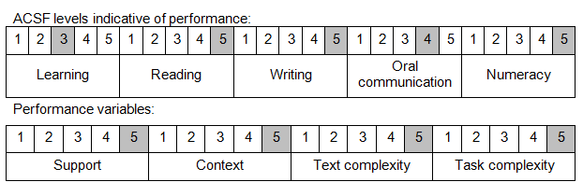

Further information on ACSF and the foundation skills underpinning this unit can be found in the Foundation Skills Guide on the GSA website.

# Unit Mapping Information

This unit supersedes and is equivalent to DEFEO007 Assess specific explosive ordnance as being safe and suitable for transport.

# Links

Companion Volume implementation guides are found in VETNet - <https://vetnet.gov.au/Pages/TrainingDocs.aspx?q=6bdbab1e-11ed-4bc9-9cba-9e1a55d4e4a9>

Companion Volume implementation guides are found in VETNet - <https://vetnet.gov.au/Pages/TrainingDocs.aspx?q=6bdbab1e-11ed-4bc9-9cba-9e1a55d4e4a9>

Companion Volume implementation guides are found in VETNet - <https://vetnet.gov.au/Pages/TrainingDocs.aspx?q=6bdbab1e-11ed-4bc9-9cba-9e1a55d4e4a9>